Pietenpol Aircamper

Operations Manual

Section 1

Performance - Specifications

Maximum Speed – sea level 100 mph
75% power 3000 ft. 70 mph
55% power 3000 ft. 55 mph

Maximum Range 3000 ft
Range with 45 minutes reserve

Rate of Climb at Sea Level 400 ft per min.

Takeoff Performance
Ground Roll - Sod 450 ft
Ground Roll – Pavement 400 ft.
Total Distance over 50 ft obstacle 2,500 ft.

Landing performance
Ground Roll 400 ft.
Distance over 50 ft. obstacle

Stall speed
Power off 29 mph

Maximum Weight 1150 lbs.

Empty Weight 682 lbs.

Maximum Useful Load

Fuel Capacity
Total 17 gal.
Wing tank 13 gal.
Nose tank 4 gal.

Wing Loading
Power Loading

Oil Capacity 4 Qts.

Engine Continental A-65-8
65 hp at 2100 rpm

Propeller Fixed Pitch Sensenich 72CK42

Descriptive Data

Engine

Number of engines: 1
Engine Manufacturer: Continental
Engine Model Number: A 65-8
Engine Type: Normally apirated, direct - drive, air-cooled, horizontally – opposed,
Carburetor equipped, four cylinder engine with cu. In. displacement.
Horsepower Rating and engine speed: 65 hp @ rpm/

Propeller

Propeller Manufacturer: Sensenich
Propeller Model Number 72CK42
Number of Blades 2
Propeller Diameter 72 inches
Propeller Type Fixed Pitch
Propeller Material Wood

Fuel
Approved Fuel Grades
100 LL Grade Aviation Fuel (Blue)
80/87 Auto Fuel ( No Alchohol)

Oil
Specifications
Sump 4 Qts.

Below 40 degrees F SAE 20
Above 40 degrees F SAE 40

Note When temperaturers overlap, use the lighter grade of oil.

Maximum Weight

Maximum Ramp Weight 1150 lbs.
Maximum Takeoff Weight 1150 lbs.
Maximum Landing Weight 1100 lbs.

Standard Airplane Weight

Standard Empty Weight 682 lbs.
Maximum Useful Load

Baggage Space
Wing Locker 10 lbs.

Specific Loadings

Wing Loading:
Empty 10.4
Maximum 17.69

Power Loading:
Empty 4.7
Maximum 7.18

Section 2

Limitations

Introduction

Section 2 includes operating Limitations, instrument Markings and basic Placards necessary for the safe operation of the airplane, its engine, standard systems and standard equipment. Observance of these operating limitations is required by the Federal Aviation Administration regulations.

Airspeed Limitations

Vne Never Exceed Speed 100 mph.
Vno Maximum Structural 80 mph
Cruising Speed
Va Maneuvering Speed
1150 lbs
Vs Stall Speed 29 mph

Marking

Green Arc Normal Operating Range 29-80 mph

Yellow Arc Smooth Air Operating 80-100 mph

Power Plant Limitations

Engine Manufacturer: Continental
Engine Model Number: A 65-8
Maximum Power: 65 BHP rating
Engine operating Limits for takeoff and continuous Operations:
Maximum Engine Speed 2300 rpm

Note
The static RPM range at full throttle ( carburetor heat off ) is 2000 RPM.

Maximum Oil Temperature: 225 degrees.
Oil Pressure
Minimum 10 psi
Cruising 30-40 psi
Maximum 85 psi

Maximum Cylinder head Temperature 550 degrees F
Appropriate Maximum Oil Consumption ¾ Pint per hour

Fuel Grade (see fuel limitations)

Oil Grade:
Below 40 degrees F SAE 20
Above 40 degrees F SAE 40

Propeller Manufacturer Sensenich
Propeller Model Number 72CK42
Propeller Diameter 72 inch

Power Plant Instrument Markings

Tachometer
Normal Operating 1500-2300 rpm

Oil Temperature 100 – 225 Degrees F.

Oil Pressure
Minimum 20 psi
Maximum 85 psi

Fuel Quantity
Wing tank 13 gal.
Nose tank 4 gal.

Weight Limits
Maximum Ramp Weight 1150 lbs.
Maximum Takeoff Weight 1150 lbs.
Maximum Landing Weight 1100 lbs.

Maximum weight in wing 10 lbs.
Baggage locker

Center of Gravity Limits

Center of Gravity range
Forward 15 inches aft of datum
Rear 20 inches aft of datum

Reference datum: Leading edge of wing

Maneuvering Limits

This airplane is certified in the Experimental category. The experimental Category is applicable to aircraft intended for operations. These include maneuvers incidental to normal flying. Aerobatic maneuvers, including spins in this aircraft are not permitted.

Flight Load Factor Limits

Flight Load Factors - Maximum takeoff weight 1150 lbs.

Kinds of Operating Limits

This aircraft is equipped for day VFR flight. FAR Part 91 establishes the minimum required instrumentation and equipment for these operations. The referance to types of flight operations on the operating limitations placard reflects equipment installed at the time of Airworthiness Certificate issuance.

Flight into known icing conditions is prohibited.

Fuel Limitations

2 tanks
Total fuel 17 gallons
Wing tank 13 gal.
Nose tank 4 gal.

Fuel in nose tank is not intended for use in any normal operations. Nose tank is intended as a constant feed in maneuvers where fuel supply may be interrupted.

Placards

The following information must be displayed in the form og composite or individual placards.

On the fuel shutoff handle.

Fuel Shutoff – Pull

Next to wing tank fuel shutoff on Cabane Strut
ON and arrow showing direction of valve operation.

Near fuel tank filler
80 / 87 Min Grade Gasoline
Fuel Capacity 17 gal.

On Wing baggage door
10 lbs. Max Capacity

A calibration card must indicate the accuracy of the compass in 30 degree increments.

On Oil filler cap
Oil 1 Gal.

Under fuel primer
Primer

On Passenger front panel
PASSENGER WARNING
THIS AIRCRAFT IS AMATUER BUILT AND
DOES NOT COMPLY WITH THE FEDERAL SAFETY
REGULATIONS FOR “STANDARD AIRCRAFT”.

Section 3
Emergency Procedures

Introduction

Section 3 provides checklist and amplified procedures for coping with emergencies that may occur. Emergencies that caused by airplane or engine malfunctions are extremely rare if proper preflight inspections and maintenance are practiced. Enroute weather emergencies can be minimized or eliminated by careful flight planning and good judgement when unexpected weather is encountered. However, should an emergency arise, the basic guidelines described in this section should be considered and applied as necessary to correct the problem.

Airspeeds for Emergency Operation

Engine Failure after takeoff 65 mph

Maneuvering speed
1150 lbs 80 mph

Maximum Glide 55 mph

Precautionary landing
With engine power 55 mph

Landing without engine Power 55 mph

Operational Checklists
Procedures in the operational Checklists portion of this section shown in Bold – Faced type are immediate – action items which should be committed to memory.

Engine Failures

Engine Failure During Takeoff Roll
- Throttle --idle
- Brakes -- apply
- Ignition Switch – Off

Engine Failure immediately after takeoff
- Airspeed – 65 mph
- Fuel Selector Valve – Pull to Off
- Ignition Switch – Off

Engine Failure During Flight
- Airspeed – 55 mph
- Carburetor heat – On
- Fuel Selector Valve – On
- Magneto Switch – Both
- Primer – In and locked

Forced Landings Without Engine Power
- Seat belts and shoulder harnesses – Secure
- Airspeed –55 mph
- Fuel shutoff valve – Pull to Off
- Magneto Switch – Off
- Touchdown --55 mph - tail low
- Brakes – Apply

Forced Landing with Engine Power
- Seat belts and Shoulder harnesses -- Secure
- Airspeed -- 55 mph
- Select field – Fly over, noting terrain and obstructions.
- Turn off avionics and beacon switches.
- Airspeed – 55 mph for touchdown
- Touchdown – tail low
- Magneto Switch – Off
- Apply Brakes

Fires

During Start on Ground if engine starts
- If engine starts -- 1700 rpm for a few minutes.
- Engine shutdown – inspect for damage

If engine fails to start
- Exit aircraft immediately
- Throttle -- Full open
- Fuel shutoff – Pull to close
- Magneto Switch – Off
- Fire extinguisher – Obtain – have ground attendant obtain if not installed
- Fire damage – Inspect, repair damage or replace damaged compoments before conducting another flight.

Engine Fire in Flight
- Fuel Shutoff Valve – Pull to Off
- Avionics and Beacon Switches – Off
- Airspeed – 80 mph ( if fire does not extinguished, increase glide speed to find an airspeed which will provide an incombustable mixture.
- Forced Landing – EXECUTE ( as described in Emergency Landing Without Power )

Landing with a Main Flat Tire
- Approach – Normal
- Touchdown – On Good Tire First, hold airplane off flat tire as long as possible.

Section 4 Normal Procedures

Introduction
Section 4 provides checklists procedures for normal operation.

Speeds for Normal Operation

Unless otherwise noted, the following speeds are based on a maximum weight of 1150 pounds and may be used for any lesser weight. However, to achieve the performance specified in Section 5 for takeoff distance, the speed appropriate to the particular weight must be used.

Takeoff
Normal Climb Out 65 mph
Short Field Takeoff 55 mph

Enroute climb
Best rate of Climb 65 mph

Landing Approach
Normal Approach 65 mph
Touchdown speed 55 mph

Maximum Turbulent Air Penetration Speed 80 mph

Maximum Crosswind Velocity 10 mph

Checklist Procedures

Preflight Inspection

Introduction
Visually inspect the airplane for general condition during the walk-around inspection. Use of the refueling steps will simplfy access to the upper wing surfaces for visual checks and re-fueling operations. In cold weather, remove even small accumulations of frost, ice or snow from wing, tail and control surfaces.Also, make sure that control surfaces contain no internal accumulations of ice or debris.

Preflight Inspection

Cabin
- Pilot Operating Handbook in airplane
- Airplane Weight and Balance checked
- Wheels Chocked
- Control stick lock removed
- Magneto switch – Off
- Fuel quantity indicator – check Quantity Airplane must be level to read quantity
- Fuel Valve – ON
- Wing Baggage door Secured

Right Wing
- Check fabric condition
- Check aileron freedom of movement
- Check aileron hinge screws
- Check aileron cable fittings
- Check pitot tube on leading edge of Wing
- Remove gust lock if installed
- Wing tie down – disconnect
- Check lift strut condition and safety wires

Nose
- Engine Oil Dipstick filler Cap – Check oil level, then check dipstick filler cap
Secure. Do not operate with less than 4 quarts.
- Fuel strainer drain on gascolator – sample fuel
- Propeller – Check leading and trailing edges for nicks and damage. Check propeller bolt safety wires
- Check inside of cooling eyebrows for obstructions
- Check air filter

Left Wing and Fuel fill

- Fuel fill cap secure
- Verify fuel level
- Check fabric condition
- Check aileron freedom of movement
- Check aileron hinge screws
- Check aileron cable fittings
- Remove gust lock if installed
- Wing tie down – disconnect
- Check lift struts and safety wires

Fuselage
- Check landing gear, tire pressures, condition of bungees, brakes and legs.
- Check condition of fabric
- Check condition of access plates under fuselage
- Check tail wheel assembly, condition of control cables
- Check rudder and stabilizer. Condition of control cables and of hinges.

Before Starting Engine

- Wheels chocked
- Preflight inspection – complete
- Passenger briefing – complete
- Seat belts and shoulder harnesses Adjust and Lock
- Fuel valve -- ON

WARNING
When pulling the propeller through by hand, make sure that the Magneto switch is Off.

Starting Engine

- Prime – As required ( 2 – 6 strokes, none if engine is warm)
- Carburetor Heat – Cold
- Throttle Closed
- Propeller area clear
- Magneto Switch – ON – Both
- Engine starts by hand prop.
- Check oil pressure
- Establish idle speed of 650-800 rpm

Before Takeoff
- Seat belts and shoulder harnesses secure.
- Flight controls – free and correct
- Flight instruments Check and Set
- Fuel quantity – Check
- Primer – In and Locked
- Fuel Valve – Re- check open
- Throttle 1400 rpm
  - Magneto check rpm drop should not exceed 50 rpm on either magneto or 50 rpm difference between magnetos.
  - Carburetor Heat – Check for rpm drop
  - Engine instruments – Check
- Throttle 650-800 rpm
- Strobe Light – as desired

Takeoff
- Carburetor Heat – Cold
- Throttle – Full Open
- Elevator Control – lift tail at 23 mph
- Climb Speed – 65 mph

Short Field Takeoff
- Carburetor Heat – Cold
- Brakes –Apply
- Throttle – Full Open
- Brakes Release
- Lift tail as soon as Possible
- Climb at 55 mph until obstruction is cleared
- Climb at 65 mph

Landing

Normal Landing
- Airspeed 65 mph
- Add carburetor heat when engine speed less than 1700 rpm
- Airspeed 55 mph on short final

Balked Landing
- Throttle – Full Open
- Carburetor Heat – Cold
- Climb speed – 55mph

After Landing
1. Carburetor Heat – Cold

Securing Airplane
- Avionics Switches Off
- Magneto Switch Off
- Control locks – Install
- Fuel Valve – Pull to shutoff

Cold Weather Operation

Special consideration should be given to the operation of the airplane fuel system during the winter season or prior to any flight in cold temperatures. Proper preflight draining of the fuel system is especially important and will eliminate any free water accumulation.
Cold weather often causes conditions which require special care during airplane operations. Even small accumulations of frost, ice or snow must be removed from wings, tail and control surfaces to assure satisfactory flight performance and handling.

Starting

Prior to starting on cold mornings, it is advisable to pull the propeller through several times by hand to “break loose” or “limber the oil.

Caution
Before Pulling through the Propeller through, Verify the Magneto switch is OFF.

Starting

- Wheels chocked
- Magnetos -- OFF
- Prime as required – ( 2 –6 strokes)
- Throttle – Closed
- Magneto switch – ON
- Area Clear
- Hand prop engine

Section 5 Performance

Cruise conditions
Total Range –no reserve
Presssure Altitude 3000 ft.
Expected wind 0
Temperature 20 degrees Centigrade

Landing Conditions
Field pressure altitude 1000 ft
Temperature 25 degrees Centigrade
Field length 1500 ft

Fuel Required
The total fuel required may be estimated by using the basic performance information for the Continental A-65-8 engine.
Figure 3 Continental Engin Manual

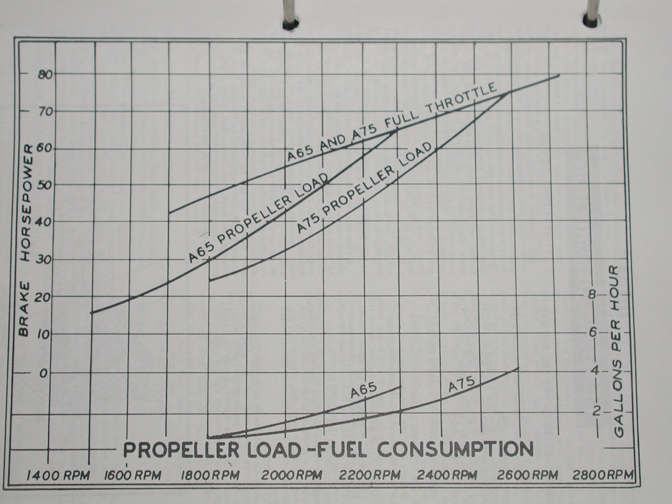

Figure Temperature Conversion Chart

Place conversion chart Here

Section 6 Weight and Balance

Place weight and balance calculations here

Section 7
Airplane & Systems Descriptions

Parts and Equipment List

Continental A-65-8

Magnetos Slick

Exhaust Luscomb

Propeller Sensenich 72CK x 42 wood

Battery 31 amp hour sealed gell 12 v.

Gascolator ACS

Fuel filter

Engine eyebrows Homemade from pattern of J-3

Compass Airpath

Oil pressure Guage 2 ¼”

Oil temperature Guage 2 ¼”

Magneto Switch A-7

Tachometer

Altimeter

Airspeed Indicator

Turn coordinater

Engine Primer ACS

GPS Garmin GPS II

Strobe light

Pilot and Passenger Seatbelt

Pilot and Passenger wind screen

2 – 12 volt outlets

- Throttle
- Carburetor heat
- Fuel shutoff
- Magneto Switch
- Fuel primer
- Altimeter
- Compass
- Airspeed
- Turn coordinater
- Tachometer
- Oil temperature
- Oil pressure
- Elt switch
- Strobe switch
- 12 volt outlets
- brake resoiver
- Brake handle
- Wing fuel shutoff

