This is the text of the articles that I wrote on the canopy. This was written before the days of quick build and pre-punched kits. I did not check to see if all of the references to parts are still valid. Some of the ideas may be out of date because of changes to the kits. Use what is useful to you and ignore the rest. The pictures that accompanied the articles are at the end.

CANOPY, OH MY CANOPY, PART ONE

Install the instrument panel first and attach F6108 and F6107L & R to it first. Then fit the F6105L & R sub-panel. This guarantees that it will fall on a straight line so that the top skin will fit correctly.

Install both the front frame roll over structure and the sliding canopy frame as a unit. Shim the sliding canopy frame as required to get the roll over bar and front of the slider frame parallel to each other.

You have built the instrument sub-panel and instrument panel and have drilled the forward top skin to the structure. Then you get your finishing kit and you find that you need to install F6109 to line up with the roll bar brace, WD-643. That means that you have to remove the skin from the underlying structure. So, how do you keep the sub-panel and F-6108 lined up so that the skin will fit back right and the rivet holes stay lined up? I puzzled over this one for some time before I figured it out. Take the skin and drill through the holes into a piece of scrap. Then use the scrap, clecoed to the flanges to keep things lined up while you drill the F-6109 to the center brace in the proper place. You can trim the scrap into the shape of a plus sign so that you have room to work.

When you set the canopy onto the frame for trimming, the tube that sticks up above the sliding canopy frame keeps the canopy from setting down onto the frame. You have to drill a hole in the canopy to get it to lay down. The chances of getting it in exactly the right place are practically nil. This means that you will end up with an oversized oval hole. Bill Bennedict says that you should just fill the space up with Proseal. I suggest that it would be better to just cut the projection off flush with the frame and fit the canopy. Then you can drill the hole in exactly the right place. Use a nylon spacer to take up the space of the cut-off piece, support the outside canopy handle and act as a bearing though the canopy.

The answer as to where to cut the canopy is to turn the canopy upside down and lay the sliding part of the frame in the "tub". It will fit well in only one place. Mark this with a marker so that when you put the canopy on the plane you will have a line to cut on.

Bill Bennedict says that if you are installing lift struts to hold up your tilt-up canopy, you should install them so that the extending strut part is pointing down. The struts are filled with oil to lubricate the strut and seal. If they are installed with the extension strut pointing up, it will not be lubricated and will fail much sooner.

If you put a 1/8 inch spacer between the aluminum angle that goes from the roll over bar support to the firewall and the center instrument panel support, you can leave the top forward skin off so that you can work on the instruments and wiring. When you get ready to permanently install the roll over bar support, after you rivet the forward skin on, you can easily get it in between the angle and the panel support. Otherwise you have to pry them apart to get it in.

When installing the roll over bar for the sliding canopy, rather than trying to clamp the C-668 spacer under the canopy frame support and the canopy rail, drill the hole in the C-668 first. Then round the outboard end so that it will lay flat, on top, inside the canopy brace. Clamp it in position and then drill through the hole into the brace and canopy rail. See section D-D' on DWG SC-2. Then you can take some double sided tape and stick the nut to the spacer in the right place and poke a hole through the tape where the bolt goes. Then rest the whole thing on a deep socket and hold in place until you get the bolt screwed in place.

Unless you really like aggravation, don't install the side rails for the sliding canopy until you fit and drill the canopy track to it. Then remove the rail and install nutplates to hold down the track to the rail. It is very difficult to get the nuts on the screws because the lower flange of the rail won't allow you to get your fingers in to start the nut or a socket or wrench on the nut to tighten it.
Page 8-11 says to trim the F-674 one inch inside of the final trim line and do the final trimming when fitting the canopy. It may be better to wait to trim this skin until after it is drilled to the bulkheads and longeron. That way the shape of the curve will be maintained as you drill forward of bulkhead F-608. If you trim it before drilling, it may get out of shape because it has no support. This will make fitting the canopy much more difficult if is out of the natural curvature of F-608 bulkhead.

CANOPY, OH MY CANOPY, PART DEUX

Last issue I mentioned that I had cut off the end of the canopy latch support tube so that the canopy could lay down on the frame. I didn't have room for the picture so I promised myself that I would include it in this issue. This does two things. It keeps the tube from scratching the canopy, and it assures that the hole will be small and in exactly the right place, rather than large and oval like most of them end up. It is nearly impossible to get it exactly right when it can't lay down in the final position. It is less likely to leak this way, too.

This is the article that many of you have been waiting for and one that I was dreading, in case I messed mine up and had to order a new one. It's a long story, but here goes. At Van's tent at Oshkosh where I was a volunteer worker, a builder came up to me and asked me about fitting the canopy. I told him about my trepidation and that I was very surprised when it turned out to be one of the easiest things that I did. Van was standing next to me behind the counter and, over-hearing my comment, said "I'm surprised too." That tells you something, doesn't it? I had been dreading fitting the canopy for a long time. I put it off, hoping to find that someone found an easy way to do it, or that Van would improve it some way to make it easier to fit. Finally, everything else was done. I couldn't put it off any longer. I had been gathering tips and hints about fitting the canopy and talking to other builders throughout my project. I sat down and read through the ideas that I had collected and organized them in my mind to develop a plan of attack. No one idea stuck out as being best, but the more I thought about it, the more clear the problem seemed. I had to figure out a way to make the compound shape of the Plexiglas fit the compound shape of the frame, even though they were not the same. My frame was fitted to the fuselage, so the Plexiglas had to be made to fit it. I was worried about scratching the Plexiglas and tried to find a way to minimize the handling of it. I finally decided that I would try the plan that I had devised and play it by ear as I went. If I messed up too bad, I could always bite the bullet and buy another one, Heaven forbid. It turned out that by using my plan with a few improvisations along the way, the canopy fitting was so simple and easy, that all of my worry was for naught. Or perhaps because of my worry, I found a better way to do it, and was able to do all of the fitting by myself. I only needed help to put the canopy on and take it off a couple of times. One thing that I didn't do was follow the plans! Normally, when I get ideas from other builders about how to do something, I like to recognize their contributions by attributing them to those who suggest them. In this case, however, what I ended up doing was using several ideas and modifying them to fit my plan. Thanks to everyone who recognizes one of their suggestions.

Before making any cuts on the Plexiglas, peel back and cut off the protective plastic about one inch back from where the cut line will be. Then tape the plastic down tightly so that no cutting dust can get under the plastic. Be sure to tape down the plastic where it overlaps. Remember that the edges get sanded for fiberglass lay-ups, so this will not expose any critical areas to scratches. Do this for EVERY cut you make. If you don't, plastic dust and some of the grit from the cutting disk WILL get under the protective plastic. The voice of experience again.

Before you put the Plexiglas on the frame for the first time, cut the stub off the slider frame where the handle goes through, as noted in part one of Canopy, Oh My Canopy. Close and lock the canopy frame. Take a look at the angle of the Plexiglas relative to the level line where it will set on the roll-over bar. Raise the sliding part of the frame so that it follows this line. This will result in the slider frame being slightly higher than the roll-over bar. Drill the frame to the wheel support tube and bolt in place. Then tape the slider frame in the closed position in several places. Remove the handle. Put masking tape on the canopy bow and slider frame where the canopy will touch so you can see the contact point better. This will be more forward than you may think because of the angle of the canopy. Put duct tape on the forward top fuselage to protect it from scratches. Get a friend to help you put the Plexiglas in place on the frame. Mark the mold line at the front for the first cut. I had planned to use suction cups to lift the Plexiglas off the frame for cutting but I found a better way, quite by accident. Take a stick about four feet long and lift one side of the Plexiglas up from the side of the frame. Slide the stick between the Plexiglas and the frame and push it towards the other side of the fuselage. Go around to the other side and pull the stick across under the Plexiglas. This will hold the Plexiglas up off the fuselage so that you can cut it in place without taking it off the fuselage or worrying about holding it on a workbench. When cutting the Plexiglas, I found that it was easier to cut using a high speed on my die grinder and making a single pass cut by using a saw tooth motion with the cutoff blade. To cut, run the blade along the cut line and then push it down to complete the cut. Then advance the blade out of the cut and forward an inch or so. Then press down again. Keeping the blade at high speed, repeat the process until the cut is complete. George Orndorff's video suggests that you make several cuts using a slow speed with the blade. I found George's tapes very helpful in a lot of ways, but in this case I do not agree with him. Remove the stick and slide the Plexiglas around until it fits against the roll-bar. Mark the rear Plexiglas ½" inside the rear fuselage skin and, using the stick as above at the rear, raise the Plexiglas up and cut on this line. The Plexiglas will now lay down on the frame. Go back to the front and carefully trim the front no more than ½" at a time until it fits the roll-bar and the rear frame of the slider. Mine only took one cut across the center to fit just right. Re-trim at the rear if it does not clear the rear skin and lay down on the rear slider frame. The Plexiglas will now fit fairly well, but it will not lay down on the frame perfectly. If you hold the front tight to the roll bar, the back bar will not fit, or vice versa. Now comes one of the first major deviations from the plans and a major leap of faith. You have to cut the Plexiglas in half. It will never fit if you don't. Center the Plexiglas on the frame and slide it back so that it fits the roll bar. It should line up with the line you made earlier when the sliding part of the frame was laid in the “tub”. Using strapping tape, pull the sides down tightly against the fuselage. Use duct tape to tape the front edge tightly to the forward fuselage. Use several layers to make sure that it is snug and cannot move. Trim the protective plastic along the cut line where the windshield will be cut from the slider and tape it securely so that cutting dust can't get under the plastic. Again, this area will be covered with fiberglass so there is no need to worry about scratches. Being careful not to cut too deep and end up cutting the tape holding the slider frame to the roll-bar, cut the Plexiglas on the line and move the rear section and the slider frame back out of the way. Mark the windshield at 4" intervals along the roll-bar and clamp it to the bar between each of the marks. Starting from the center, drill on the marks where the Plexiglas contacts the roll-bar. This will be more forward than you may think. Be sure to keep the drill perpendicular to the Plexiglas at the point of contact. This will not be vertical! It will be tilted forward and, as you work your way around the frame, tilted toward the side as well. Use a fine 3M Roloc pad in a die grinder and polish the edge of the Plexiglas. Replace the slider frame and the rear section of Plexiglas and mark for drill spacing. Trim the front of the slider Plexiglas so that it fits the front windscreen when laying down on the slider frame. Then tape it securely in place. Starting in the center, drill and cleco the Plexiglas in place. When you come to a hole that will need a spacer under it to make it line up with the windshield, stop. Use spacing material on the outside of the slider portion until you find the thickness that, when laid on the outside, will just line up with the top of the Plexiglas on the front portion. When you have determined how thick a spacer is needed, slide the canopy open. This will be easier if you use a piece of rope tied to the slider block at the rear so that you can lift and pull the rear up and aft without pulling on the Plexiglas. The first time you open the canopy to install a spacer, you can back drill the latch hole and temporarily install the latch and handle to use to open and close and lock the canopy. To save time you can determine the thickness needed to shim the Plexiglas by doing one on each side of the centerline. DO NOT drill another hole until the first hole that needs a spacer is drilled and clecoed in place with the spacers installed. If you do, the holes will not line up when you install the spacers. Take your time and do only one hole on each side at a time. For spacers, Sears sells #6 Nylon washers .063" thick that work perfectly.
I got the front bow all drilled and it matched the front windshield almost exactly. No place required more than two Nylon washers to line up. When I started to drill the centerline tube, I had my first major revision to my plan. The first three holes went OK, but each hole required more spacers. When I got to the forth hole, I could see that the trend was not good. In

fact, the contour was not even close to the frame. I tried pushing down and couldn't even get close. I tried heating the Plexiglas. No help. I was stumped because the rear bow fit perfectly with just a slight pull on the tape holding it in place. I had not even checked the fit of the center tube up to this point. I called Van's and, after discussing several alternatives like welding a new tube with the correct contour, it was suggested that I could use MARINE TEX epoxy filler to fill the gap. This stuff comes in white or gray and has a 15000 PSI crush strength. It can be drilled and tapped. It says on the can that it can be used to repair engine blocks! It is fuel and oil resistant. Mixed 5 to 1, it makes a very thick sticky blob that will not sag or run. It is available at most boat supply stores. I drilled the Plexiglas to the rear bow as above. No spacers were required. I removed the Plexiglas and frame. I then put packing tape where the filler would go and then clecoed the Plexiglas to the frame with the spacers in place on the front bow. With the assembly upside down on a plastic garbage can, I used a Bondo squeegee to press the Marine Tex between the Plexiglas and the frame. While I was at it, I did the front bow too, so that I wouldn't have to put the shims in. The Marine Tex doesn't stick to the packing tape. I scraped the excess away so that the finished frame was the same width as the original frame. The stuff didn't sag. It filled the space perfectly. I then drilled and tapped the center tube for the #6 screws.

Next, trim the side of the Plexiglas exactly even with the top of the side tubes of the frame. Remember to trim the protective plastic and tape it down before cutting. You can make fitting the side skirts (C659 and C660) a one man job by marking a centerline on the horizontal frame bar. Notch the C659 for the overhead bars and hold it in place. Mark where the centerline is on each end. Remove it and draw a line between the marks. Pre-drill the holes in the C659 along the line at the specified 1½" spacing. Reinstall the C659 so that the line drawn on the frame is visible through the pre-drilled holes. Start in the center and drill it to the frame, making sure as each hole is drilled and clecoed, all of the holes still line up. You will note that the side tube is not straight, but is curved to match the contour of the fuselage. In order to drill the C660 outer panel, the curvature must be maintained. Note that the C660 has a natural curvature. Take advantage of this when deciding which way to face it to the C659. You can make a one man job out of back drilling this panel. Make a wood female jig by setting a 2 by 4 on the edge of the fuselage rail where the slider goes and marking the curve of the side of the fuselage on it. Then take a jig saw or band saw and cut out the curve. Hold it up to the fuselage to make sure that the curvature is right. Mark the center of the jig. Line up the top edges of the C659 and C660 and clamp them together. Back drill one hole in the center. Then set the two parts in the jig and drill through this hole into the center of the jig. Cleco in place. Recheck the alignment at the top edges. Then press down as you back drill and cleco each hole starting in the center. Drill and cleco the lower row of holes that join the C660 and C659 This will result in the parts maintaining the proper curvature when removed from the jig. Next remove the parts from the jig and drill the holes in the C660 that will be used to screw the C659 and the Plexiglas to the plastic mounting strip. Cleco the C659 and C660 to the frame with the Plexiglas sandwiched between them. Back drill the holes into the Plexiglas and the C659. Remove the C659 and back drill into the plastic strip that will be used to secure the #6 screws through the C660, Plexiglas, and C659. Make a very shallow countersink in the holes in the plastic on the side that faces outboard. This will make it much easier to get the #6 screws started in the plastic. Rivet the C659 and C660 together at the bottom only. Be sure not to rivet the holes that attach to the frame. Cleco the assembly back to the frame and install the #6 screws through the Plexiglas into the plastic strip. Put the canopy back on the fuselage. Check to see how the skirt matches the contour of the fuselage. If it does not, you can push or pull on the assembly to make it line up. Then remove one cleco at a time and pop rivet it to the frame, holding it in place as you rivet. You will find that the right side will tend to stick out because the curvature of the right side tube does not match as well as it does on the left. I noted that almost all of the RV's at Oshkosh had made some sort of adjustment on the right side. I had to bend mine in a bit, which is not easy unless you have a metal shrinker, because you need to create a compound curve. One builder fluted his to fit and then riveted an additional strip of skin on the outside to cover the flutes. Unless you knew that the strip was extra, you would never suspect what was done. It looked quite good. I used my shrinker to get a good fit.

When tapping the holes for the #6 screws, be sure that you only turn the tap ½ turn and then back it out a bit to clear the chips that are cut. If you don't, the chips will build up and you stand a good chance of breaking off the tap. So speaks the voice of experience, not once, but twice! If you do break off a tap and can't back it out, take a Dremel and completely grind around the broken tap so that you can back it out. I tried pulling the Plexiglas off a broken tap that I couldn't get out and ended up breaking off a corner of the windshield. Fortunately, it is covered up by the fiberglass frame. You can fill the hole with J B Weld and re-drill it.

When you have the Plexiglas clecoed to the frame and the side skirts installed, the fun part comes. If you follow the plans, you must make a flat piece of tempered aluminum fit two different curves at the same time. This requires a compound curve, something that it just doesn't want to do. George Orndorff told me that he had to make more than one to get a good fit and that many builders have had the same experience. He says it is easier if you get a softer (condition O), and perhaps thinner aluminum and use it instead. You have to decide what is best for you. If you decide to stick with the aluminum, the best way to try to get it to fit is to start at the bottom and drill and cleco a couple of holes. Then have a friend pull and twist the skin down as you drill and cleco toward the center, trying to hit that tiny tube of the slider frame dead center. You then must shrink or stretch the edge to get a decent fit. I know of some builders who had to make several before they got one that they were satisfied with. One builder even considered going into the aluminum wholesale business so that it wouldn't cost so much for the material. Good luck.

After trying to see how mine was going to fit, (NOT!), and seeing how much trouble it was going to be to try to hit the narrow canopy tube while drilling a blind hole through the skirt and Plexiglas, (LOTS!), I decided to use fiberglass. I left the Plexiglas long rather than cutting it off along the line of the tube. My fiberglass skirt fits perfectly. It is a bit heavier than the aluminum and required a bit more finishing, but it fits absolutely perfectly. I used four layers of fiberglass on the outside and after that cured, one layer on the inside. I used packing tape on the fuselage to keep the lay-up from sticking. Be sure to use colored packing tape. The clear tape is hard to see and remove. When doing the lay-ups, be sure to use Polylite peel ply cloth over the fiberglass as the final layer. This will peel right off when the lay-up cures and save a lot of sanding and filling later. After the lay-up cures, fill the jog between the slider and the fuselage with Bondo or filler and sand to a smooth contour.

When masking the Plexiglas to do the fiberglass lay-ups, use strapping tape and then masking tape on top of that. When the lay-up cures, it will be much easier to remove the tape. If you just use masking tape, it will tear and leave lots of little pieces that have to be removed. This increases the chances of scratching your canopy where it will show. When doing the lay-ups around the front of the canopy, don't use the rolls of fiberglass tape. They will not lay down as you form them around the compound curves. Get a large piece of E-glass and cut diagonal strips about 4" wide. Roll them up so that they are easier to use. Rather than wetting them out like George Orndorff does on his video, paint a thin coat of epoxy resin directly on the fuselage and windshield and then unroll the diagonal cut fiberglass a few inches at a time and lay it down. You can control the width by how much you pull on the roll. If you pull too much, you can just lift it back up and spread it wider with your squeegee. The bias cut fiberglass will lay down perfectly with no wrinkles. Then wet the cloth out with epoxy. Repeat the process for the other layers using dry cloth. The fiberglass rolls will work OK for the top of the roll bar because the curve is not so compound. It does have one drawback, however. The edges of the tape are thicker and need to be sanded off when the lay-up cures. An easy way to cut the bias strips of fiberglass is to lay the cloth out on a flat surface that you don't mind cutting and then use an Olfa roller razor running along a straight edge like a pizza cutter. To finish the fiberglass lay-ups, first fill all of the obvious rough spots and sand smooth. Get a spray can of gray or white primer and paint the lay-up. This will expose lots of defects that you didn't see the first time. Fill those with spot glazing putty and sand smooth. Prime paint again. E-GADS!!!, more pinholes! Fill and sand those. Paint again. Those little suckers must be reproducing when you are not watching, because sure enough there will be some more to fill. After the third fill, paint, and sand routine, you should have gotten all of those little blighters. If not, just fill them and touch up with prime paint. When you do finally get them all, sand with 400 grit or finer sandpaper for the final finish for painting the color coat. With a little effort, you can end up with a lay-up that is as smooth as glass.

Hope this helps. Jim Cone

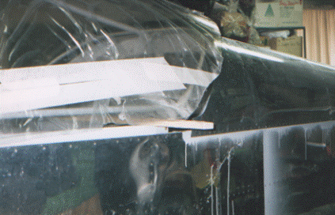
Stick holds canopy up so that it can be cut in place.
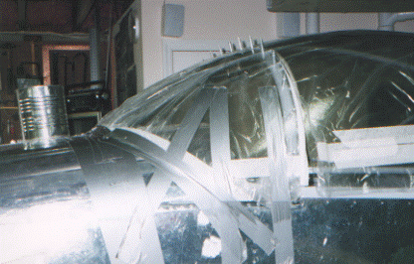
TAPE IN PLACE SECURELY

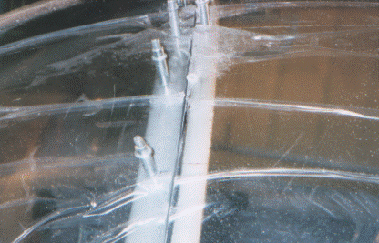
LAY SPACER ON OUTSIDE OF PLEXIGLAS SO THAT IT LINES UP WITH TOP EDGE OF WINDSCREEN
NOTE THAT I DIDN’T CUT BACK THE PLASTIC AND TAPE IT LIKE I TOLD YOU TO DO. I GOT LOTS OF DUST UNDER MINE. ARRGHHH!!! ‘NO POINT IN REPEATING MY MISTAKE.

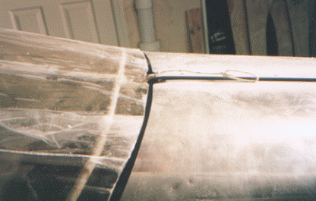
USE ROPE ATTACHED TO SLIDER BLOCK TO OPEN CANOPY

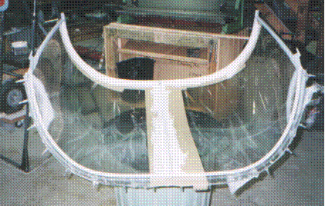
MARINE TEX BETWEEN THE BAR AND THE TAPE COVERED PLEXIGLAS

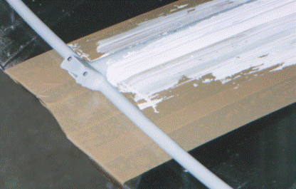
Close up view.
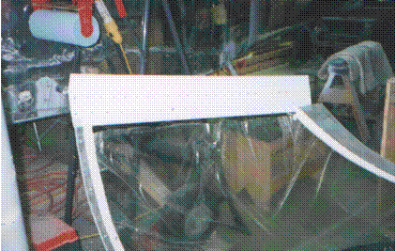
WHILE OFF THE PLANE THE SIDE SKIRT IS EASILY INSTALLED BY ONE PERSON

