Photo 1: Ken holds “one year of college.”
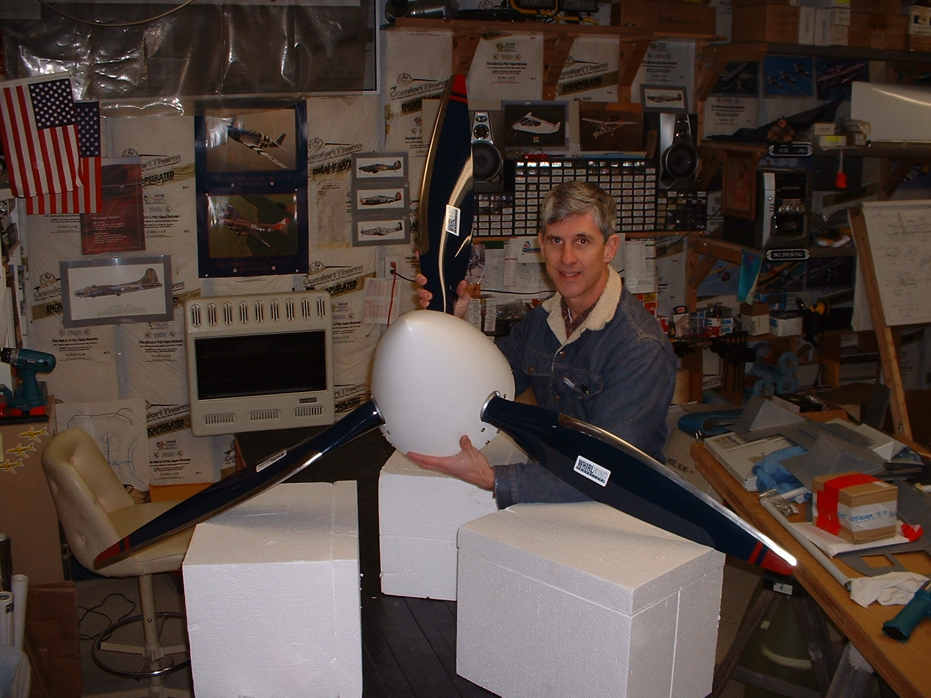

Photo 2: Blade tip detail
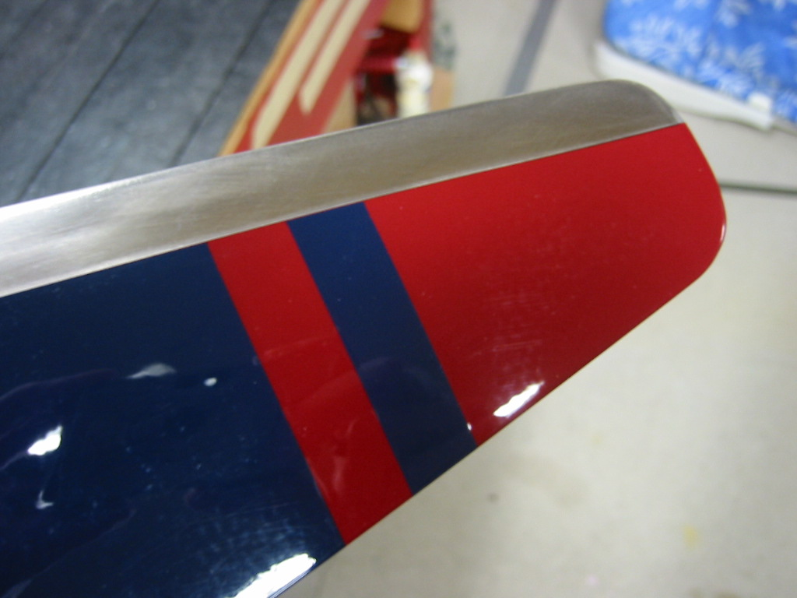

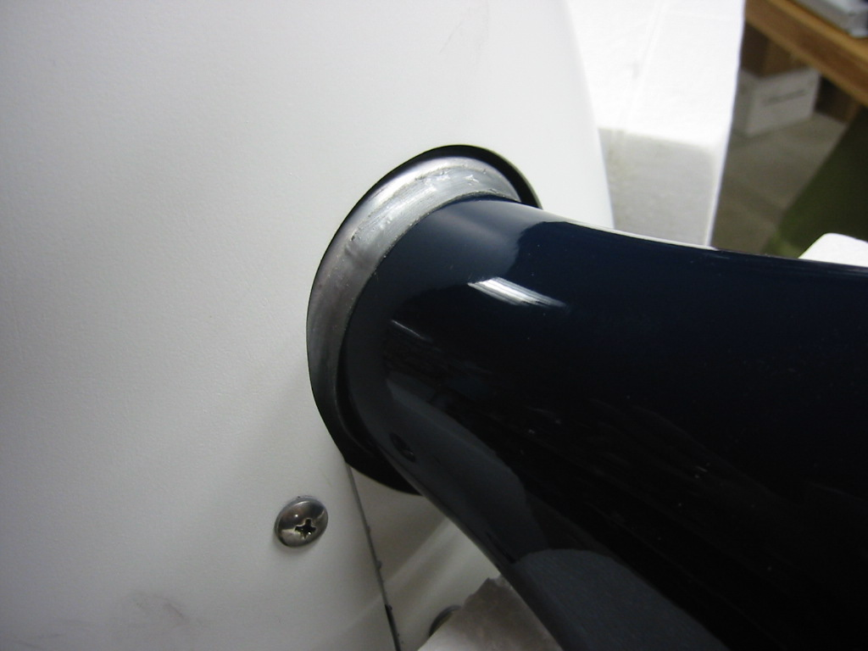
Photo 3: Spinner – hub detail

Photo 4: Prop installed – front view
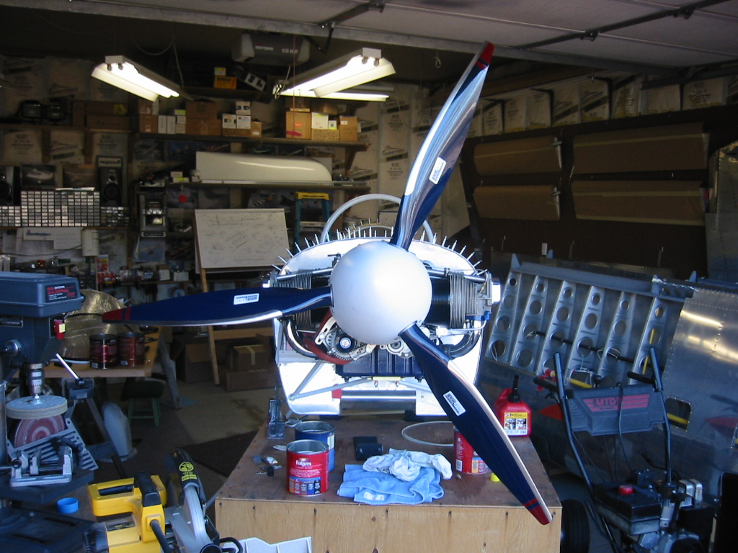

Photo 5: Quarter-front view with engine
