Stall/spin - Could you be the next statistic?
Over the last 30 years slightly more than 7 people have died on average annually in UK register small plane stall spin accidents. To put that in perspective ditching accounts for only one death roughly every 3 years, and if you exclude those who did not have the wit to wear a lifejacket and to fly the plane down to a controlled water landing it is only one death in something like 20 years. Yet in my experience most people see the risk of ditching as more serious than that of a stall spin accident. This may relate to the fact that most of my flying acquaintances and probably most readers consider themselves to be pretty good pilots, and with this I suspect there comes a sort of feeling of invulnerability:
Accidents are things that happen to other people, particularly basic mistakes like stall spin accidents!
Sadly this is just not true. A number of expert studies have revealed the following sobering facts: 1) Experience is no protection – Stall/Spin deaths are significantly more common in PPLs and CPLs (who face roughly comparable risks) than in solo student pilots. 2) Having an instructor on board is no protection – 22% of Stall/Spin deaths occurred with an instructor on board and student pilots were more likely to suffer this fate with an instructor than flying solo. 3) Most GA planes take more than 1000ft to recover from a spin even in the most expert hands, so a spin in the circuit is almost inevitably fatal.
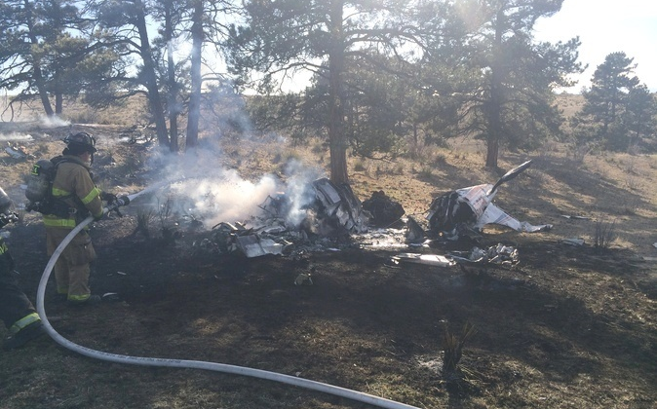
Fig 1. Not a happy ending Photo: Diane Lord, Aurora Fire Dept.
The fatal stall spin accident in a Lancair following an engine failure after take off, described in last August’s Light Aviation by Mike Barnard nicely illustrates the point. The pilot was 45, had 4500 odd hours, plenty on type, was an instructor and examiner in multiple aircraft types and a graduate of the US Navy Test Pilot School. No one better to send your child flying with, you might well think, but he spun to his death with his passenger.
The first essential in avoiding becoming a statistic is to accept that it could happen to you.
Before you come to the conclusion that the only sensible course is to give up flying, let me say that I believe there is now quite sufficient information about why and how even experienced pilots can be victims of unrecoverable stall/spin accidents to allow us to plan effective measures to eliminate or at least dramatically reduce our own risk. The following appear to be well established:
1) Psychological studies have shown that the brain (even a woman’s!) is a single channel processor for conscious thought. You can only analyse one problem at a time. This is different from saying you can only do one thing at a time. Thoroughly rehearsed/trained actions like keeping a plane on an even keel or keeping a car in its lane can be carried out by the subconscious part of the brain using what might be termed muscle memory.
2) In stressed situations, the brain will tend to focus extremely narrowly on a single area which is deemed to be crucial to resolving the crisis. This narrow focus will be to the exclusion of all other things (like instrument scans) which need conscious input and analysis.
3) Although every conventional plane will spin, some are more prone than others. Planes with light elevator control surfaces are more prone to spin. For instance the stall spin accident rate of the Cessna 150 is many times higher than that of the 152, correlating with the higher and more progressive elevator control forces of the latter. Also wing design matters. The PA 28 with tapered wing has a stall/spin accident rate dramatically lower than its constant chord wing predecessor. Lightweight, low inertia planes are also at greater risk.
4) It is my own experience observing my own and other people’s driving behaviour, that when they are heavily distracted they will maintain good road position but tend to slow down markedly.
5) This all fits with the conclusion that in highly stressed situations pilots will tend to slow the plane because of a subconscious desire to slow things down whilst resolving the immediate problem of ‘Where the Hell can I land?’. This is likely to be aggravated by increased muscular tension, which inevitably accompanies severe stress, tending to increase back pressure on the controls, and also probably by the trim not having been adjusted to the new flight conditions.
6) The UK gliding movement has managed to virtually eliminate stall spin deaths by insisting that all pilots, however experienced, do practice stalls, spins and cable breaks (effectively an EFATO) with an instructor every year. The average glider pilot has probably done more than 30 practice cable brakes and experienced several real ones in his gliding career – the equivalent of switching off the engine and throwing the key out of the window. Naturally they (the survivors!) get to be quite good at it! The average pilot has also practiced numerous stalls and spins before ever being allowed to go solo, and many like me would make a habit of spinning any new glider they flew, just to be happy with its behaviour.
The large majority of stall spin accidents happen in the vicinity of an airfield and at or below circuit height, from which there is no escape. A few happen as the result of unwise low level beat up manoeuvres or aerobatics gone wrong, but the large majority relate to an engine or propeller problem or some other major distraction. Some happen away from airfields perhaps stretching a glide to get back, or in mountain flying or in relation to a water crossing – indeed half of the last 22 year’s UK ditching deaths could be classed as stall spin accidents. My working model for how the bulk of these events occur is as follows:
Major distraction -> Major Stress -> Narrow focus on landing possibilities -> Neglected speed control + subconscious desire to slow down events + tension in arm muscles -> Speed decay +/- use of rudder -> Stall/Spin
Despite every pilot knowing that with an EFATO one should always land ahead, in fact in many instances it is clear that the pilot has attempted to turn and very probably has used an undue amount of rudder, thus initiating a spin rather than a straight stall. My thesis is that there are three main ways in which you can equip yourself to avoid following this fatal sequence:
a) Fit your plane with a low speed warning system which you cannot ignore.
b) Know precisely how your plane performs in an emergency
c) Do meaningful practice of dealing with emergency situations.
a) Low speed warning system
Like most GA pilots I have a stall warner, which squeaks in the head rest behind me. There are a number of problems with this: 1) It doesn’t make much noise and is rather non specific, and whilst I have been growing somewhat deafer with age my head sets have become more sophisticated and much more efficient at shutting out external noise! 2) It sounds for a significant portion of the take off and landing runs, so I am used to ignoring it. 3) I do not have the figures but it is a reasonable assumption that the majority of the GA fatalities also had a stall warner which they ignored.
The major studies of stall/spin accidents have found that ATPLs have much lower risks than PPLs or CPLs, (equalled only by solo students). It is not reasonable to ascribe this to their superior piloting skills as they have very little hands on flying compared with CPLs. It seems much more likely that it is the built in slow speed warning systems such as stick shakers and loud spoken warnings through their headsets, (aided perhaps by the superior skills of George), that keeps ATPLs safe - the Air France Airbus being a very rare exception.
I am entirely persuaded that a system giving clear, escalating oral warnings of decaying speed is capable of preventing the majority of stall/spin accidents. Ideally such a system is Angle of Attack based or alternatively has built in g sensors to combine with airspeed to give a true prediction of the stall approach phase. There appears to be a move in the States to introduce such systems for certified aircraft, but effective instruments already exist for Permit aircraft. The only system that I am personally familiar with is the SmartASS. This is a beautifully simple and inexpensive (under £200) bit of kit made in the UK by Smart Avionics, which the average LAA pilot or anyone who ever owned a Meccano set, would find very simple to fit, just plugging it into the pitot system, plus a few wire connections. I know that it has saved at least two lives (one an experienced ex instructor in an EFATO out of Lydd). The SmartASS is an audible air speed speaker, with two modes, the first which I rarely use, simply telling you your speed at intervals. The more important mode is used on approach or take off. When initially setting it up and steady at your normal approach speed (at 60 kts for me) you press a button for 3 seconds and a nice female voice (Barbara) says “Chosen speed 60 kts” and then “Speed Good” in a calm voice at intervals as long as you stick within a few percent of that chosen speed. Barbara has three different messages as you get slower (and the equivalent if you overspeed): “ Speed Slow”, “Speed Very Slow” and “Speed Very Slow” preceded by a loud gong! As you stray further, Barbara’s nice calm ‘speed good’ tone gets progressively more aggravated, you could almost say ratty, and it is no more possible to ignore her than it would be to ignore your wife with the wind in her sails, fresh from having caught you in some grievous sin of omission!
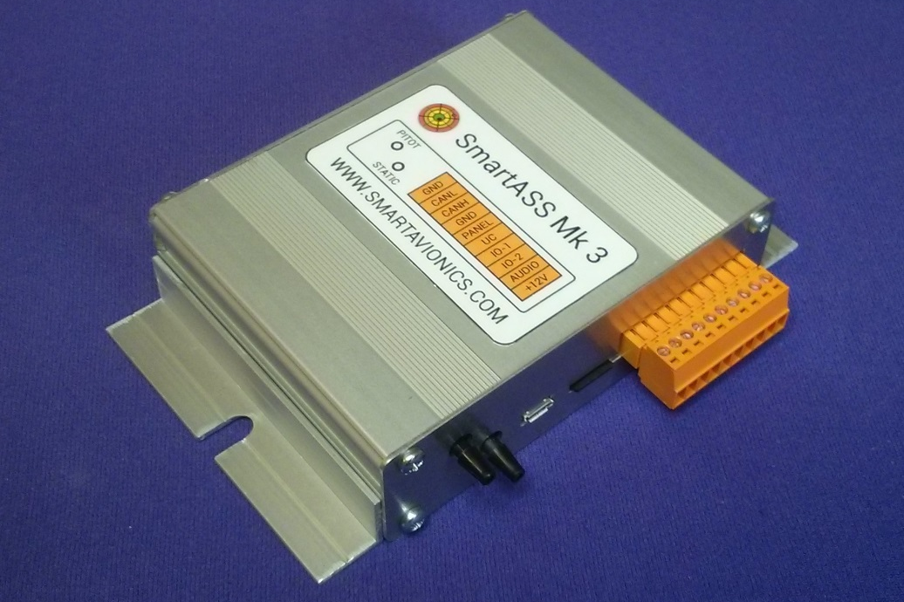
Fig 2. The new Mark 3 SmartASS. This ‘box of tricks’ measuring about 4.5 ins. and can be put anywhere.

Fig 3. The Mk 3 SmartASS control, a single multifunction knob with twisting on/off, volume function and push button mode change.
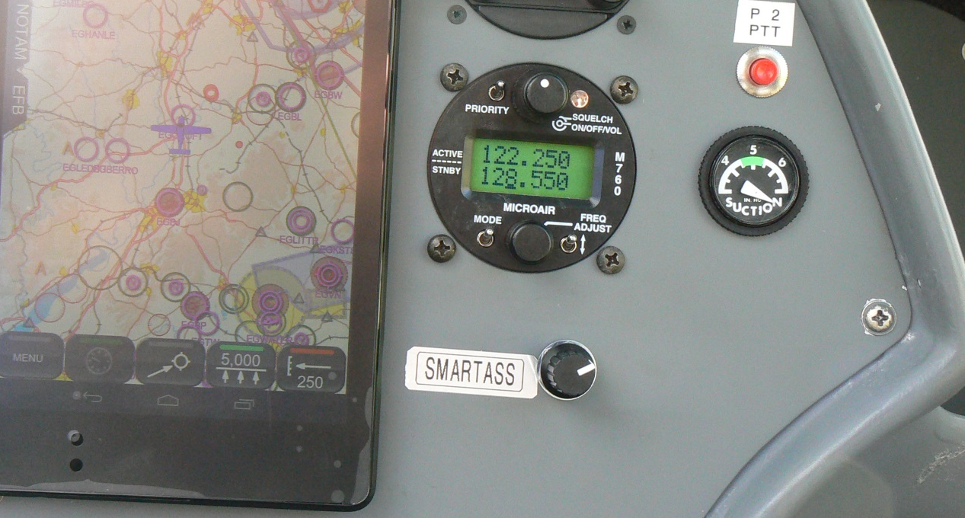

Built in accelerometers mean that if you pull significant g whilst keeping speed the same she compensates and will tell you that speed is slow, effectively keeping the same margin over the stall that you started with. That is to say that the instrument gives the same true indication of ‘Lift Reserve’ as an AoA system. When flying away from the circuit a touch of the button has her saying, “Goodbye” and being quiet until automatically waking up as your speed gets to within a few percent of your previously chosen approach speed. You can readily set the chosen speed to a new one simply by pressing the button again when at that new speed. The Mark 2 SmartASS went out of production at the end of 2013 but the new Mark 3 is just coming onto the market at the time of writing. It incidentally has an ‘undercarriage not down’ warning system built in.

Bendix King have recently introduced their KLR 10 system in the US. It relies on Angle of Attack measured by a sensor attached to a panel under the wing. The indicator is designed to sit on top of the instrument panel right in front of the pilot’s nose. In normal use just one coloured bar will be illuminated at a time with green corresponding to normal cruise attitude, yellow to lower circuit speeds, blue to a normal approach, and the red bits corresponding to differing grades of ‘too slow/too great an AoA’. As with the SmartASS there are three graded audible warnings: “AoA!”, “Caution too slow!” & “Pitch Down!” Without having flown with this system I cannot make a valid comparison, although I think I am more likely to snap to attention for Barbara than for the KLR 10 male voice. Videos of both systems in flight can be found on line. The KLR10 has two distinct disadvantages – its cost of around $1600 and it has relatively complex installation and set up requirements.
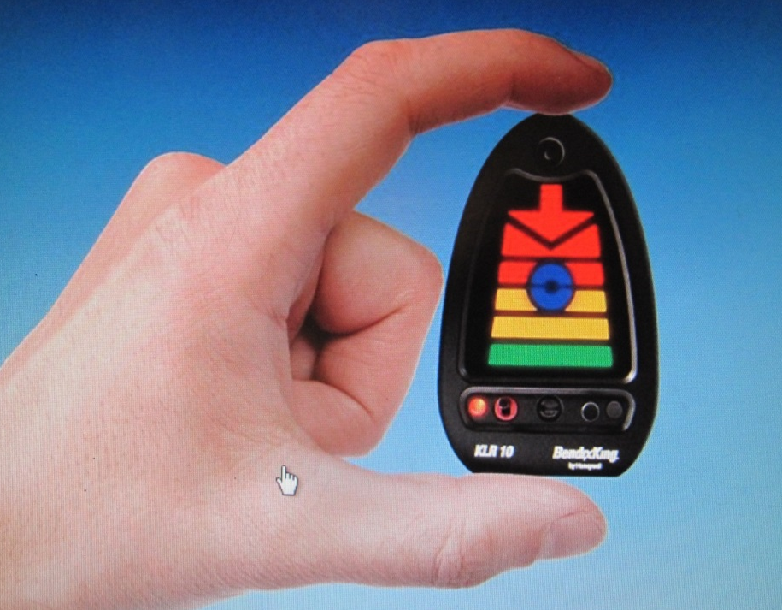
Fig 4.The indicator for the Bendix King KLR 10

I see one of these systems or an equivalent as very much being a powerful ‘Guardian Angel’ who would have prevented the majority of the stall spin deaths that I have any personal knowledge of. Can you think of a better way of investing £200?
b) How does your plane behave in an emergency?
You may wonder how this is relevant, but I promise you it is. In my experience very few pilots (including a number of instructors) know what is the most efficient way of turning round with the minimum loss of height, and few have a precise idea of their glide angle with the engine idling or stopped, and cannot confidently work out whether they can glide back to their airfield from any given height and distance. Very few again have a clear idea of at what height they could sensibly consider turning back after an EFATO. Not knowing these things in an emergency inevitably leads to indecision, increased stress and very probably to making the wrong decision.
Let us take two examples: Firstly imagine you have just taken off from one of the South Coast airfields to do a direct crossing straight out to France. At 6 miles out and 3000ft the engine goes quiet. Hopefully you will have the presence of mind to do a U turn, whilst sorting out your options and before your speed decays too much and whilst checking restart procedures! I know (because I have measured it accurately) that my Europa glides at 70 kts at a 1 in 12 angle, so from 3000 ft I have a range of 36,000 ft which is as near as makes no difference 6 nm. In nil wind the best I can hope to do is touch down on the shoreline, and even with a brisk tail wind the best I can hope to achieve is to cross the coast at a few hundred feet. Either scenario is a recipe for disaster. There is an overwhelming temptation to ease the nose up to stretch the glide, and any attempt to turn (because the airfield isn’t quite where you thought it was or the straight ahead patch is all built up) will supply that final nail. Much, much safer to make your SOS, tell them precisely where you are and do a nice well controlled ditching – mortality risk possibly 1% whereas crossing the coastline at 200ft could carry a mortality of 50% or more. So the message here is: Be certain of your best glide angle and convert this into an easy formula – for instance 1 in 12 is the equivalent of 2 miles per thousand feet. You can very rapidly work out how much height you will have by the time you get to where you want to go and if this doesn’t leave you a good margin for manoeuvring, then land somewhere else, even if that is in the water. If you don’t know your glide angle, then do some accurate tests next time you go flying on a quiet day. And in passing, the concept of ‘Within gliding distance of shore’ is a potentially dangerous one.
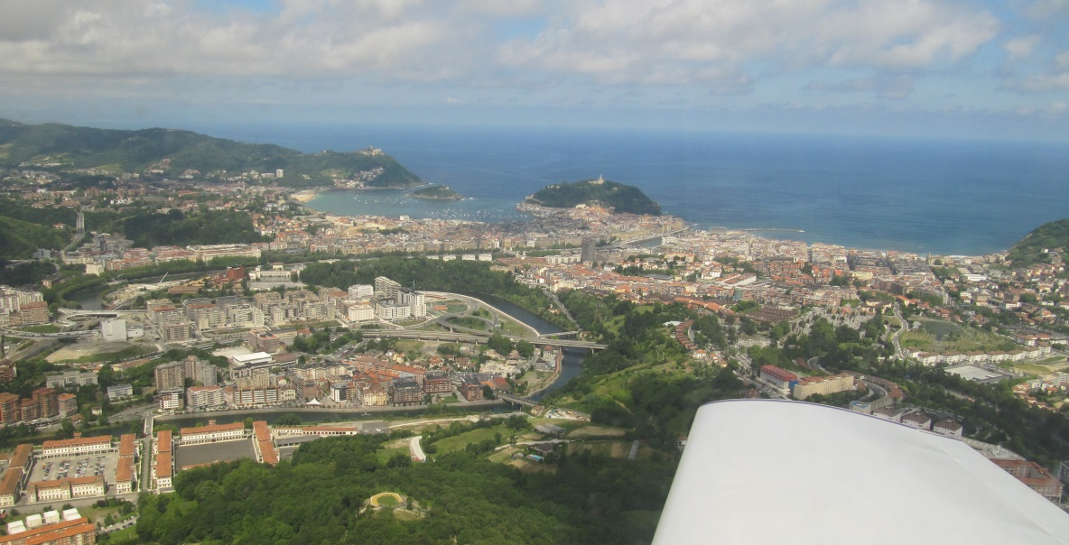
Fig 5. “Within gliding distance of shore!” Do you fancy your chances anywhere near here, coasting in at under 200ft?

Next time you are flying along a shore think what sort of shape you would be in if you passed over the shoreline at say 200ft. Along the Channel coast of the UK around half is built up and large swathes have high cliffs or woods. The concept would be better phrased as:
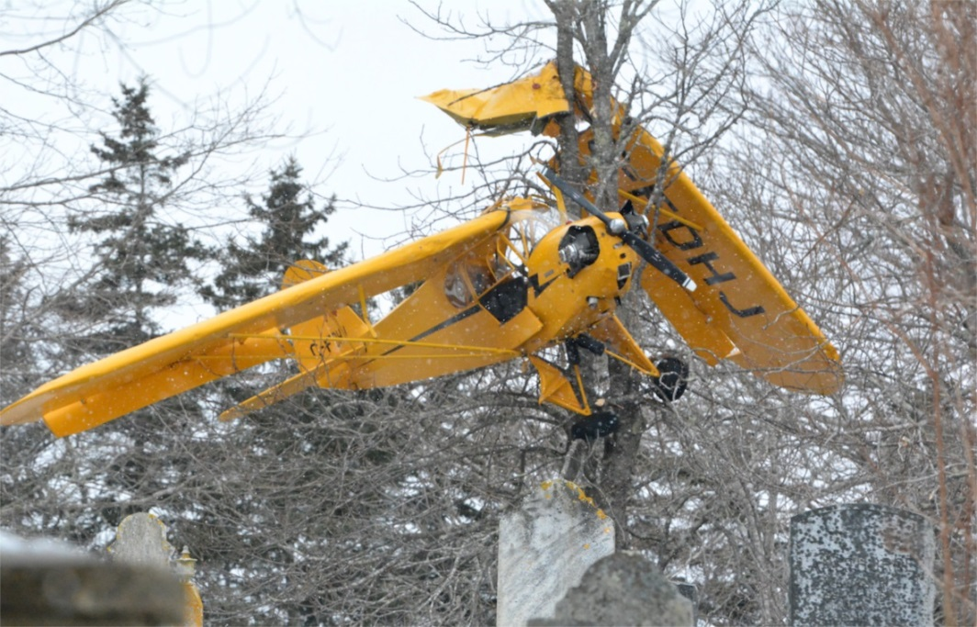
‘Within gliding distance of crossing the shoreline at a minimum of 1000ft.’ Incidentally US studies have shown over 90% survival for those landing in trees – likely much better than in a housing estate.

Fig 6. Trees offer safer landing possibilities than housing estates!

Photo: Tina Comeau, Yarmouth NS Vanguard

In my second example imagine your engine fails after take off at 800 ft. Ahead are the suburbs of some city with no clear landing areas. What do you do? Is 800 ft enough to turn around from? Your instructor said always land ahead within a narrow angle, but you can’t remember any height stipulation and you never practiced an EFATO at 800 ft and certainly not in such an unpromising place as this. After some time frantically mulling over the options (and losing speed and height) you decide that landing ahead will probably kill you and therefore you will turn around. If you
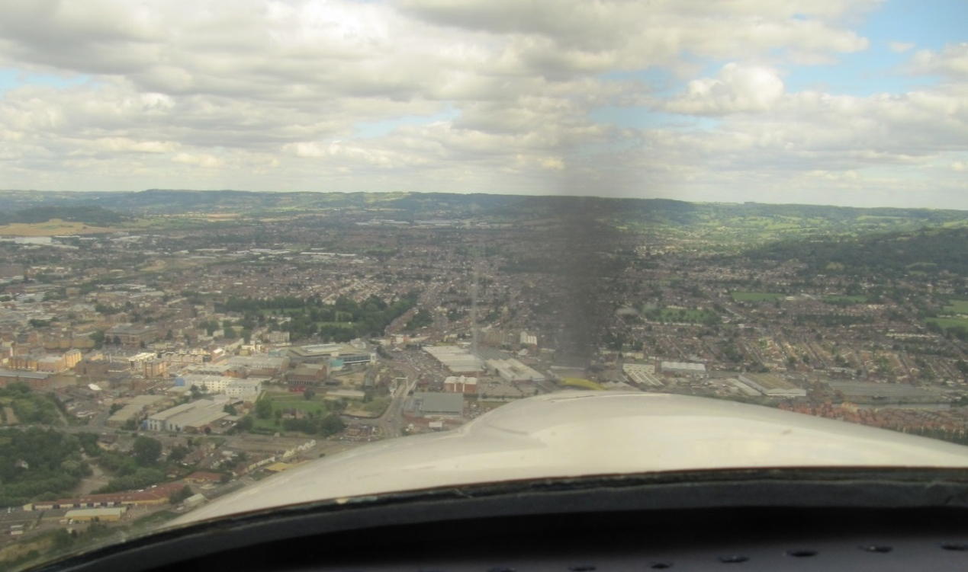
Fig 7. Engine gone quiet! Fancy landing ahead here? Best of luck!

are lucky you haven’t let your speed decay already to the point where the plane is just waiting for the merest twitch of the rudder or even the increased g of a gentle, coordinated turn before falling out of the sky. How best to turn? Nearly everyone I have asked says ‘fly at best glide speed at a bank angle of either 30 or possibly 20 degrees’. If this is what you do you will not get back to the airfield. Extensive expert mathematical studies have shown that the best way of turning with minimal height loss is at 45 degrees bank with speed as near to stall as you can manage. Table 1 shows the diameter of turns for any plane at typical small plane speeds and banks;
Table 1 Diameter of turning circle in ft. at differing speeds and bank angles.
Speed: Bank Angle in degrees: 20 30 45
50 kts 1260 790 445 feet _______________________________________________________________
60 kts 1800 1120 640 feet _______________________________________________________________
70 kts 2450 1530 870 feet
There is a nearly four fold difference between the 50kts/45 degrees figure and the commonly assumed optimum of 70kts/30degrees, let alone 70/20. The 70/30 turn takes you over a quarter mile from the centreline and the 70/20 option nearer half a mile. With the 50/45 choice there is a likelihood that you will drift much or all of the 445 ft back to the centreline, always assuming that you were awake enough to turn into any crosswind. It is tempting to calculate height loss from these dimensions on the assumption of a 1-12 glide angle, but it doesn’t work that way. As soon as one turns the glide angle deteriorates and the only way of knowing how much height you would lose in completing a turn is to go and measure it in your plane. It is easy to measure height loss whilst completing a 360 degree turn. This is very close or identical to the height loss in the sort of ‘P’ turn needed to get back to your original runway centreline, in the absence of favourable side wind drift. For my monowheel Europa (which is aerodynamically more efficient than most small planes) the measured figures are shown in table 2
Table 2 Measured height loss to complete a 360 degree turn with engine idling (in a Europa XS Monowheel)
___________________________________________________
Speed/Angle of Bank: 70kts/30 degrees 50 kts/45 degrees
Height Loss: 1070 ft 440 ft
___________________________________________________
So on the face of it I could hope to get back to the airfield reasonably comfortably from 800 ft at 50kts and 45 degrees, but if you followed your instincts and tried the faster, less banked option, you would have no hope at all, and might find yourself doing the fatal thing of easing up the nose in the hope of going a bit further. These figures are incidentally also highly relevant if you find yourself forced to turn in a valley. Some of my more sporting friends have suggested they might do a stall turn or a wingover to turn around after an EFATO or in a valley, but such aerobatic manoeuvres need appreciable starting speeds, typically over 100kts. If as is likely your speed is already low, forget it. Simply to speed up from 70 to 100kts needs a dive of 230 ft, without taking air resistance/drag into account, so probably at least 300ft. and likely to need more nerve and presence of mind than most will have available in such a crunch situation!
This of course glosses over the question of whether you can hope to safely do a slow, well banked turn with the engine out, and I certainly wouldn’t suggest that you wait for your next EFATO to find out. You clearly need to experiment at a safe height and work out what does it for you. My Europa stalls at about 38kts level and at about 45 kts at 45 degrees, but I find it surprisingly comfortable turning at 50kts/45deg (with flaps down). So I know now that if my engine fails at 500ft or more and the view out the front looks awful, I can turn with every prospect of safely heading back towards the airfield. Whether you have the range to reach the airfield is another matter depending on its length and your climb rate before the engine failure. There is also the possibility of course of there being a perfect golf course or playing field off at say 90 degrees. The key thing is that you know how to turn efficiently and have practiced doing it. Incidentally the figures above were achieved with the engine idling, which is widely accepted as adding more drag than a stopped propeller. For my 914 Europa with Woodcomp high twist W blades, the prop still windmills at 50 kts engine off, so it is academic for me, but for those whose engine will stop rotating the actuality should be more favourable than an engine idling practice scenario. The process of doing the 50/45 turn is so unusual and involves having the stick further back than normal, that it readily grabs your attention, and as you are effectively no longer frantically looking for a landing site it seems much less likely to lead to unintentional speed decay.
Should the engine go quiet at a lower height or should there be reasonable landing options ahead, what speed do you adopt? Again many I have spoken to have said best glide speed, but you are in effect on short final, so I would suggest that adopting your normal approach speed or even a short field approach speed with the gear down is what you should aim for immediately after correcting your nose up attitude. Hitting a tree or a wall at 50kts is a whole lot less damaging than at 70kts.
The energy of impact is virtually double at 70kts compared with 50kts, (98% greater to be precise)
One final bit of emergency performance to mention is side slipping. Sadly it is not taught in the PPL syllabus and I get the impression that relatively few GA pilots
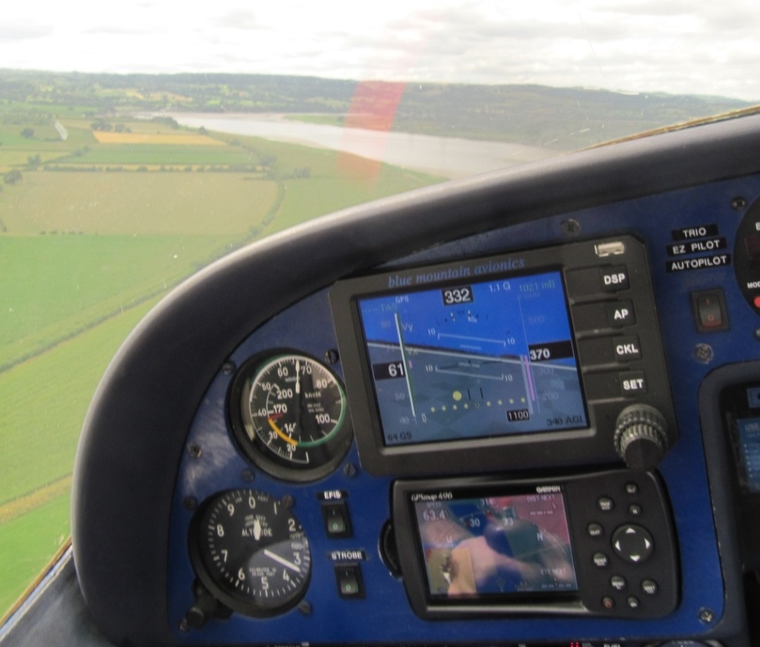
Fig 38 My plane in a full right rudder/ ball off to the left, side slip, showing 1100fpm down at about 65kts, instead of my usual idling descent rate of around 550fpm. No problem with that field ahead!

ever get on top of it. The large majority of Permit aircraft are capable of safe, effective side slipping. I suggest to you that it is an important tool in any emergency landing. How often with a power on landing do you find yourself suddenly sinking faster as you approach the fence, and have to put in a good dollop of power to touch down where you originally intended? The same risk of course is there for power off approaches (wind shear or some other aspect of Sod’s Law!). You may possibly have the luxury of being able to aim a third of the way along an 800 yard field, but it is much more likely that you will be sweating to get it into barely 300yds, knowing that you have to aim short if you are not going to end up a real mess in the far hedge or wall.
If you are comfortable side slipping, you can routinely go in a bit high and burn off any extra by side slipping once you are confident of not undershooting. Alternatively if it becomes apparent that you cannot make your chosen field it is a useful, potentially life saving tool in getting it down in some sort of shape in the previous field, rather than hitting the hedge/ditch/wall at full flying speed.
c) Meaningful Practice
I suspect there are few of us who don’t sometimes just go flying for the pleasure of getting off the ground, and we just wander round the locality admiring the view before landing. I suggest that these sort of flights shouldn’t just serve to boost that feel good factor but should be used regularly to practice key skills. In addition, if you don’t already know the answers, you should take the opportunity to explore your plane’s performance in emergency simulations. Do accurate measurements in still air of your descent rate (time how long it takes to descend 1000 ft) at different speeds with engine idling (or off if you have the welly!) so as to be able to compute glide angle. And I strongly recommend doing 360 degree turns at a safe height and over some readily seen linear feature, to measure height loss at various speeds and bank angles. This will let you know what is the most efficient way to turn your plane, in case you find you have to. If you are not confident side slipping then practice it at a safe height.
Then with any of these ‘Just out for a potter’ flights I strongly suggest you make a habit of doing one or more PFLs, an EFATO straight and turning (at height) and some practice “Can I glide there” calculations? Then that surge of ‘Feelgoodness’ that we all get from being in the air can be augmented by a bit of ‘Feelsmartness’ knowing that you have sharpened your survival skills!
To summarise - Being absolutely clear how your plane performs in emergencies significantly reduces the risk of you making the wrong decision or suffering from indecision long enough to seriously aggravate the situation. Installing a Smartass or equivalent ‘Guardian Angel’, provides you with a powerful means of preventing lethal speed decay and on its own probably removes 75% of your risk. Practicing key manoeuvres and skills regularly makes it much more likely that you will make the right decision and carry it out successfully, thus removing most of what risk remains.
You may have correctly got the impression that I am a bit evangelical about stall/spin accidents. This largely came about from having been uncomfortably close to the appalling accident at Kemble (my then home airfield) a few years back, where a father and daughter spun in after take off from around 500ft. The details, as the BBC is wont to say, are too unpleasant to recount here. I should also add that I have absolutely no financial interest in Smart Avionics, nor alas in any other avionics firm! For those who took the trouble to read my previous articles on the subject, I apologise for a degree of repetition but I was persuaded by John Beeswax to write again because I have developed the theme a bit further in ways that I hope you will find interesting and above all helpful.
Happy Landings, David Joyce

