Main & Emergency Air Valve Upgrades
By Jason Berman
The required valves are available from Swagelok.com. They typically cost $120 and we usually take three weeks to arrive. The valves are stainless steel ball type rated for 2500psi and are rebuild able. They operate with an easy quarter turn open close handle. You will no longer have to tighten a valve with gorilla force to get them to seal. Another benefit is the easy indication of open and close. If the handle is pointed parallel to the fuselage the air source is open.
!!!WARNING!!!
The following instructions are just a guideline; you’re free to make any changes you’d like. No two Cj’s are plumed or laid out the same. You may have to modify the installation to accommodate your system.
There are 4 installation options.
- Replace just the main valve
- Replace the main and both emergency valves
- Replace the main and front emergency and leave the original back valve
- Replace the main and front emergency and remove the aft valve and cap the lines
Required parts
- Swagelok SS-43GF2-A- RD (Red Handle For Emergency System)
- Swagelok SS-42GF2-A (Black Handle For Main System)
- Piece of aluminum sheet 2.25 x 2.25 x .032 - .060 thick. One required for each valve replaced
- 1/8 NTP caps Qty 2. Your choice of brass or stainless. Brass is available at any hardware store. These are needed if you decided to permanently remove the aft valve.
- 1/8 NTP female couplers and an assortment of male nipples various lengths. This depends where the gauge is located in relationship to the valve; more on this later.
Required Tools
- Flat blade screwdriver
- 7mm deep socket
- 17 mm wrench
- 5/32 drill bit
- 3/32 drill bit
- Brake away lock wire for the emergency handle
- Something to make a 9/16” hole. Personally I like a uni-bit.
- Thread locker high strength
- Permatex 56521 High Performance Thread Sealant. It’s available on amazon for $24.00; I find it works better than Teflon Tape.

Emergency Valve Replacement:
I recommend starting with this valve as it’s the easiest.

- Remove the seat and cockpit sidewall panel.
- Remove the 17mm B-Nuts going to the valve.
- Remove the handle from the top of the valve.
- Remove the three screws holding the valve in place; the nuts require a 7mm socket. Be sure to save the hardware as it is used to hold the aluminum plate the new valve attaches to.
- At this point you should be able to remove the valve.
- Make note the angle of the 90˚ flared elbow; you will need to mimic the angle on the new valve. Remove the flared fittings from the old valve. Give them a good cleaning before putting the thread sealant on. Install them into the new valve.

You should have something that looks like this; it will always be configured this way.

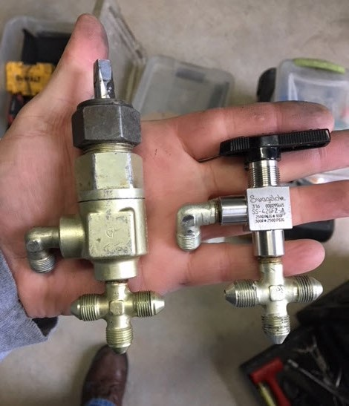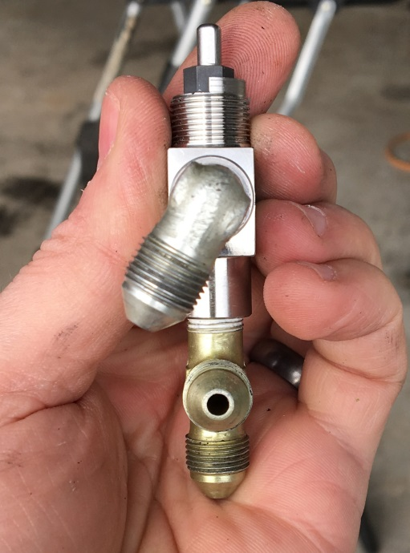

- Here’s where it can get tricky. Notice in above picture on the left; you see that the new valve is shorter in the area above the fittings. Go ahead and connect the new valve; you’ll notice the valve is an inch or so below the panel. In most cases there is enough flex in the lines to GENTLY move (bend) them up till the valve is touching the underside of the panel. The further the gauge is from the valve the easier this will be. The below diagram address the problem that occurs if the air gauge is very close to the valve. This is just the way I do it and is by no means the only way.

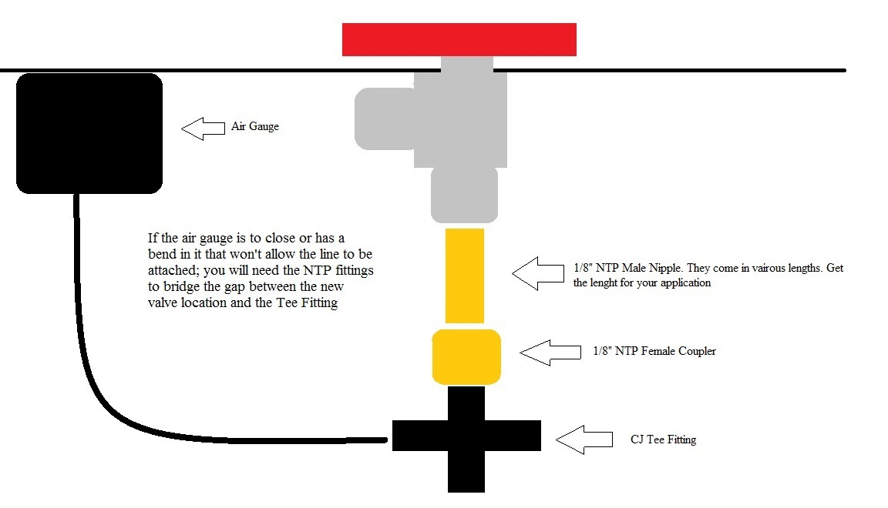
- Once you have the lines sorted out; remove the valve and set aside.
- Take a piece of the 2.25 x 2.25 aluminum square and place it under the panel. Try to keep it evenly spaced so that none of the three holes are too close to the edge. Once you’re happy with its location mark and drill the three 5/32” holes. Temp Install plate with clecos or screws and mark the center of the hole for the valve and drill a 9/16” hole. Make sure to deburr all holes and paint if you want.
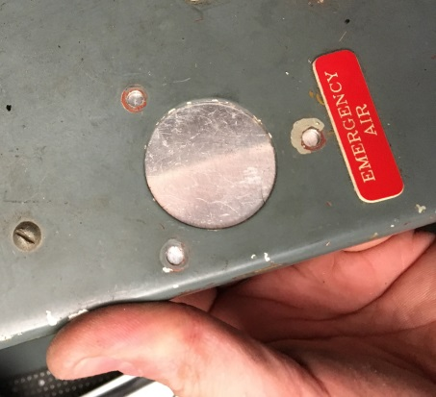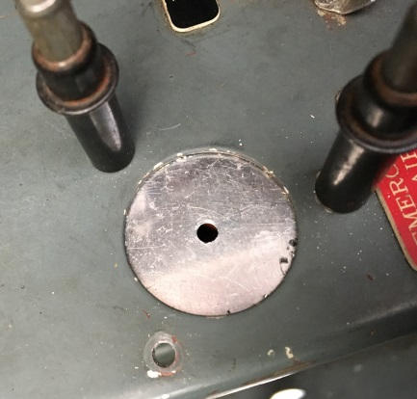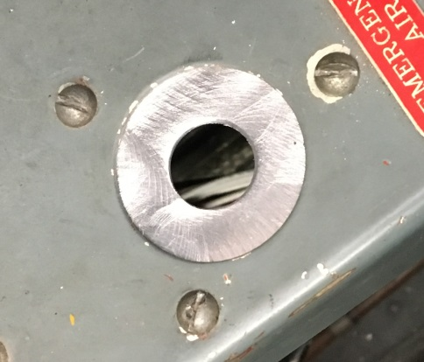

- Permanently install plate will saved fasteners. Install the air valve put some thread locker on the nut finger tight for now. Connect and tighten all the airlines. Go ahead and tighten the crap out of the valve stem nut.
It should all look like this.

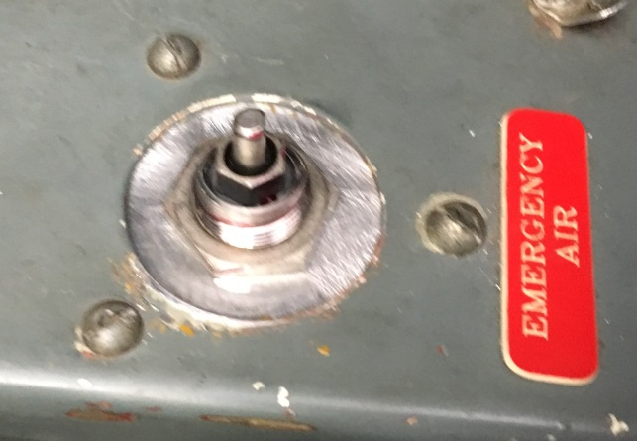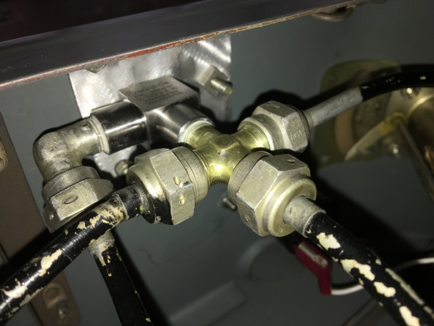
!!!CAUTION!!!
When performing ops checks crack the valve open !!SLOWLY!! This will allow the air to flow in a controlled manner while on jacks.
When closing the valve it is NOT necessary to tighten the handle like your old valve
- With the handle closed (the arrow should be pointing outboard) Perform a leak and ops check using whatever blow down procedure you normally do.
- Once you’re happy with the way it works drill a 3/22” hole through the tip of the handle and lock it in place with breakaway wire.
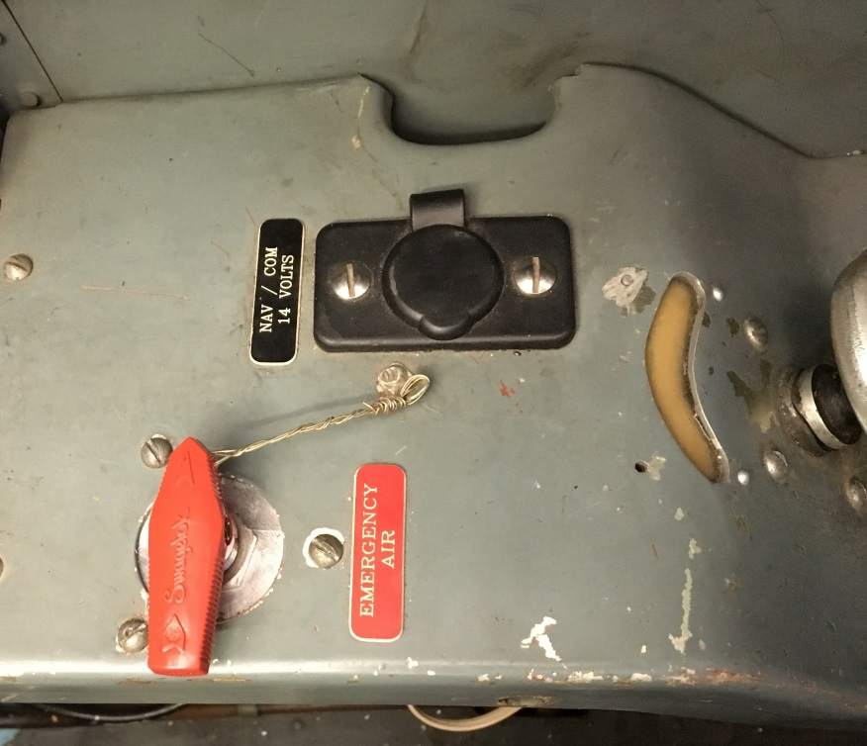

Back Seat Emergency Valve Permanent Removal:
If you don’t care to have any type of emergency valve in the back seat; it can be easily deactivated.
- Remove the sidewall panel.
- Remove the 17mm B-Nuts going to the valve.
- Remove the handle from the top of the valve.
- Remove the three screws holding the valve in place; the nuts require a 7mm socket. Be sure to save the hardware as it is used to hold the aluminum blanking plate.
- At this point you should be able to remove the valve.
- Remove the Tee Fitting and 90˚ elbow from the old valve.
- Apply thread sealant to two 1/8” NPT caps and install them onto the removed fittings.
- Reinstall the fittings back onto the lines they came off of. Secure the lines if needed and perform leak check.
- Make and install a blanking plate like above.
- Below is how the system with the removed AFT valve will look and work.
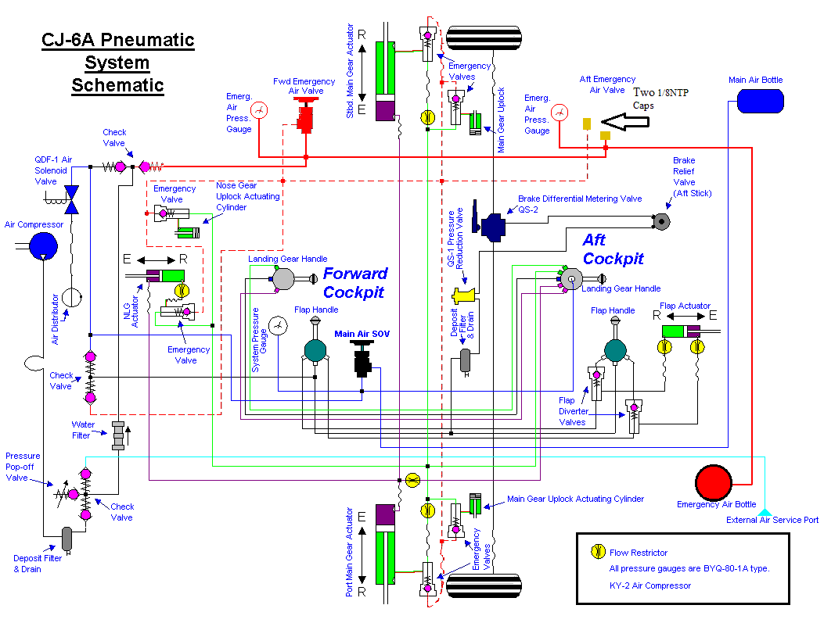

Main Air Valve Replacement:
It’s pretty much the same as the emergency. The only added difficulty is getting the lines to connect to the new valve. Because that area is filled with other airlines and engine control linkages you may have to removes lines from their holding brackets in order to get them where you need them to go. Once again every Cj is plumed different.

If you run into any problems or have questions feel free to contact me: jasonwberman@gmail.com

