A faster Flap Drive System for Kit Aircraft
By Bud Yerly

Many of my owners complained about the slow flap drive linear actuator sold in many aircraft. There are faster actuators but once limit switches and fastening safety concerns are met, it seems we always end up with a flap drive that is slow, taking as long as 8 to 10 seconds to lower and raise flaps. Combine that with a flap switch that must be held up or down for that long is more than boring, it is a nuisance. One solution is to shop for a faster linear actuator or put a different switch which does not require the pilot hold the switch when setting flap positions.

My background was in fighters and trainers where half flaps was an emergency procedure. So a momentary flap down switch was normal. Most civil pilots are taught a bleeding of the flap action so the builder of an experimental aircraft has to make a choice on his preferred switch. Flap retraction cannot be too fast, as in a touch and go or go around situation, one could enter a stall or have to make uncomfortable trim changes quickly without a switch with a momentary up position.

I have a very, very early version of the Europa Trigear. My flap drive actuator is a Motion Industries actuator of 4 inch throw 85615 with the Rod end fitting.

The Motion 85615 Linear Actuator provides a miniature package for operating loads up to 100 lbs.
It is available through Motion Systems Corporation, 600 Industrial Way West, Eatontown, New Jersey 07724

The basic construction incorporates the Motion Ball Screw which is a high efficiency .331 diameter Epicyclic Ball Screw with integral freewheeling at stroke ends to eliminate limit switches. It is a 12 VDC motor with a 4 inch throw. Brushes are available through Motion so repair is easy.

In its initial installation, the servo had a MW4 Heim rod end joint of ¼-28 thread. The rod end was secured with only a jamb nut. With a high torque motor and fast action, it was not uncommon the jamb nut would loosen. Suddenly the flaps would fall free in a trail position. This was a disaster. However, Loctite was used initially but most of us just drilled the end of the drive rod and installed either a roll pin or cotter pin matched to the hole size. Of course, one had to install the entire servo mechanism, test, rig, then take the linear actuator out and drill and pin it.

The beauty of this servo is it is quick at 1 inch per second, and if it hits its limit, the motor runs but no additional force is put on the drive. That torque and quickness, as I said, could loosen any stop nut. The enjoyable part was the stock Europa DPDT (ON) OFF (ON) switch only had to be hit for a second to bleed flaps up or down. You could hit the switch for a second and have ¼ flaps. Pretty nice. But safety considerations indicated a slower movement of the actuator would be prudent (but boring) and limit switches would automatically stop the motor from continuing running at its stop limits.

Caution:
Although the threaded rod has a lock nut, it is extremely likely that the threaded rod end will unscrew unless secured. Although Loctite is very effective, I find that once the drive is set for full up and secured, it is best to cross drill and pin the MW rod end. When damage or misalignment of the flap drive occurs (or somebody sits on your flap bending your flap drive tube) the check nut may no longer be able to be used so a cross drill and pin is essential.
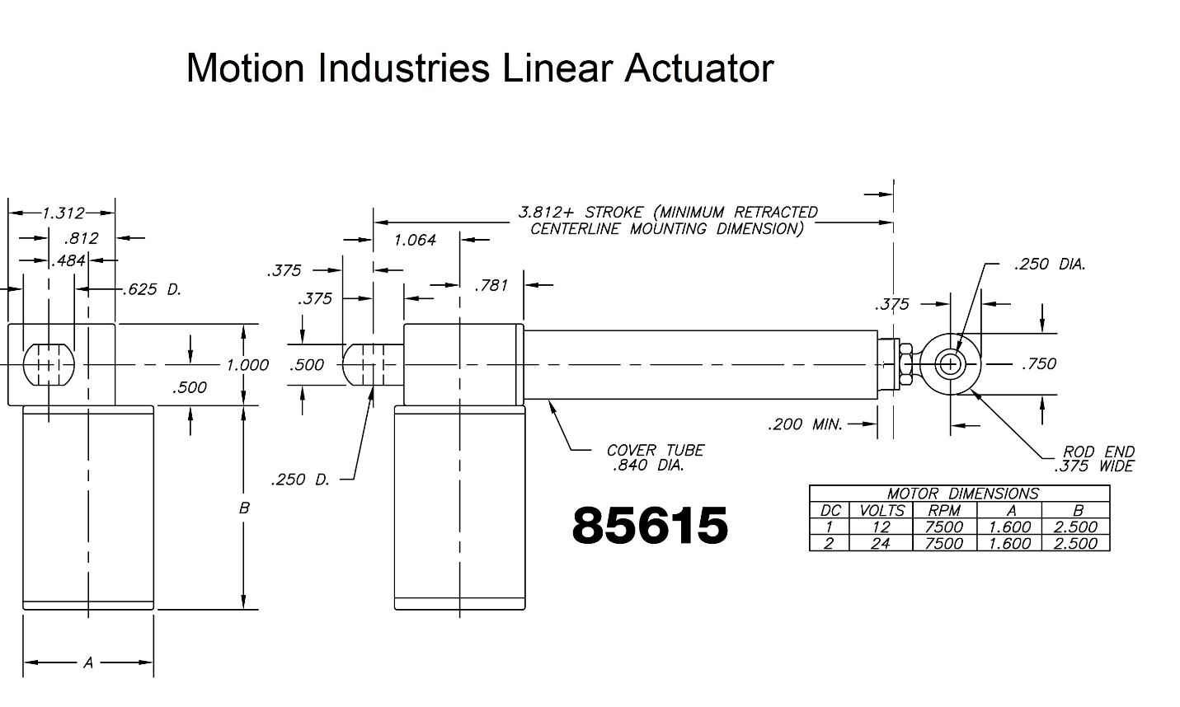
See Photo below for a typical cotter pin safety:

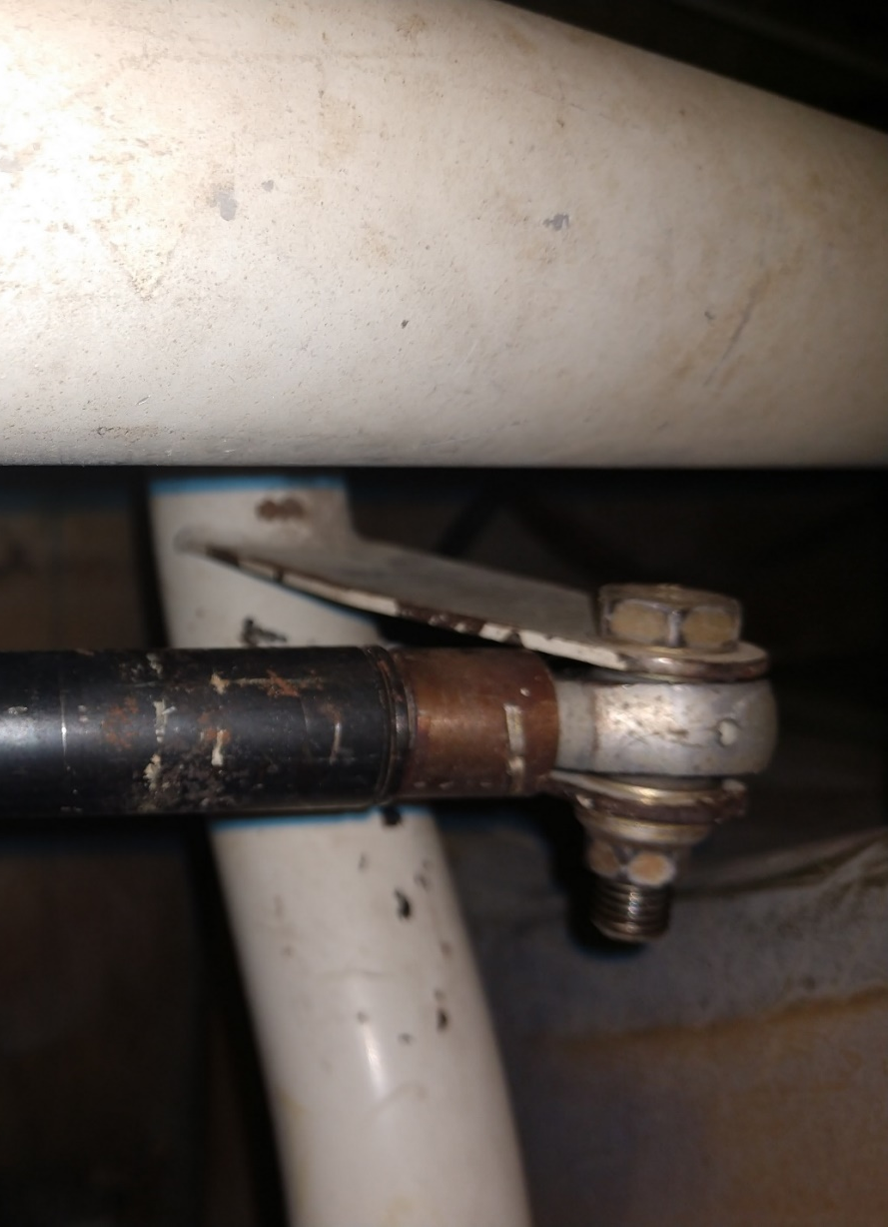

The installation of the servo is to the floor of my Europa Aircraft using an aluminum angle bracket bolt and spacers supplied by Europa Aircraft in their standard Trigear Flap Conversion Kit (See picture below). Structurally it is bolted and bonded to a ply plate, and additional glass and is rigid and strong. Motion Industries has different configurations for the aft support bolt (normally a ¼ inch hole in a cast extrusion and the hole should be requested to be horizontal (90 degrees to the motor vertical axis) as the actuator will pitch up and down) so I made my own spacers to simplify the installation. Of course a vertical hole will work provided the support is modified to allow proper pivot. In the Europa Kit Aircraft, the installation point is in an awkward to reach position. Dry running the assembly on the bench is highly recommended.
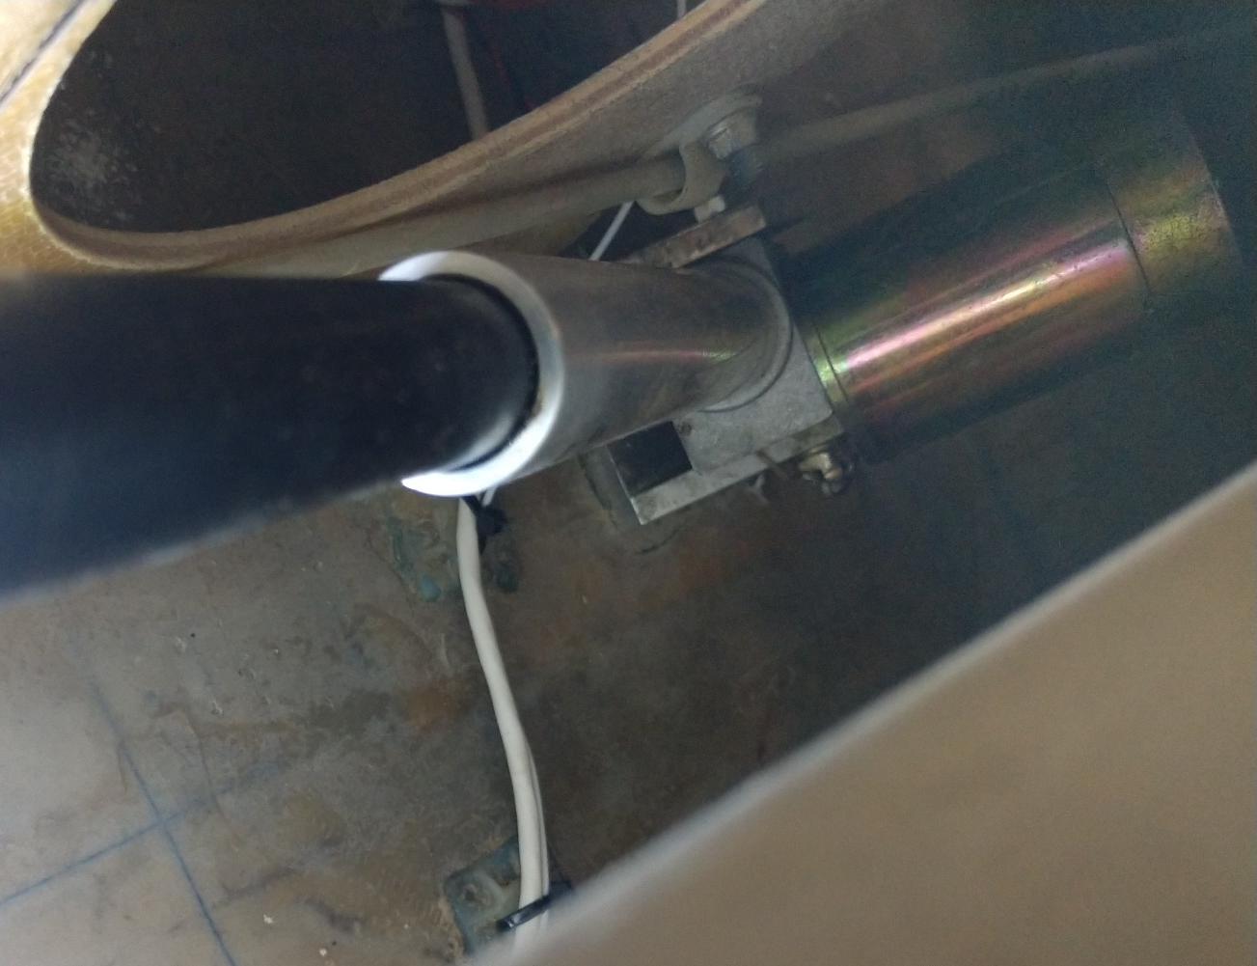

The switch to activate the flap drive linear actuator I recommend is a DPDT ON-OFF-(ON) type. As stated before, the actuator has no limit switches, so the motor keeps running if the switch is left in the up position using this type of switch. I find resetting the switch to off after the flaps are up is easy as the motor can be heard in the quiet cockpit unless ANR type headsets are used. This up switch mod makes touch and go flap repositioning quite easy and fast. One must use caution not to inadvertently retracting the flaps prior to flying speed being achieved. With the 914 engine, acceleration is so quick and flap trim changes are small and I find it a non-issue. In a heavily loaded 912 aircraft, such would not be the case, so one should stick with a DPDT (ON) OFF (ON) momentary on for down and up, to prevent that old sinking feeling after a full or partial flap takeoff.
Wiring of the flap drive is IAW the Europa Build Manual. Should a different type switch be required to look more like a flap switch, it is fairly easy to modify a DPDT switch with a flap type handle.

Most DPDT switches have a baton that will rotate. Eaton has a series of switches with a flat lever baton which does not. This type switch can have a flap type handle which is fine to prevent confusion with other switches. A friend of mine modified my round baton switch to have an extension with a flap like extension for ease of use. See photo below:

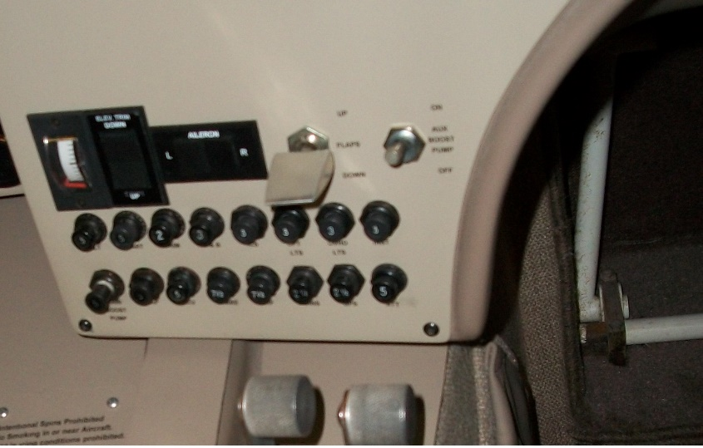

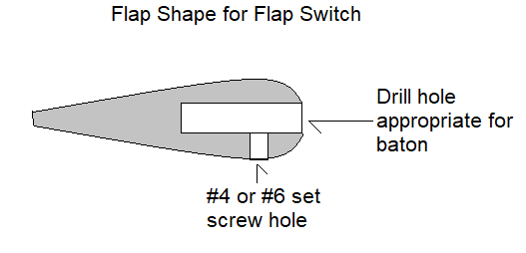
This type of aluminum machining is fun on a winter’s night with nothing to do but make an airfoil shape out of ¼ inch by 1.5 inch aluminum stock. Drill a hole suitable for the baton and drill and tap for a set screw as shown below:

Modifying an aircraft requires permissions in some countries. Check with your regulating authority.

