Commentary on the Pietenpol Airfoil

By Michael Shuck, Copyright 2004

Airfoils are really cool things. They don’t exist anywhere except on paper or on computer screens or…on the profile of a real, three-dimensional wing. The airfoil is the profile, or shape, that the wing takes from the “end on” view. That specific shape determines the 2-dimensional pressure coefficients and coefficients of lift that are demonstrated over the wing in a simulation of flight.
Saying that an airfoil creates a certain Clmax (maximum coeffiecient of lift) doesn’t begin to tell the whole story. Important to the mission of the aircraft are the Cm (pitching moment) and the drag, Cd. Simply put, drag slows the vessel down. Drag decreases its ability to climb faster. Pitching moment, usually negative, is the force that drives the “nose” of the airfoil downward. The more negative the Cm, the more so the potential of the airfoil to “point down”. Pitching moment also adds drag in the form of trim drag to the aircraft, thereby decreasing both cruise speed and climb rate. Pitching moment is that really neat force that makes your airplane suddenly point straight down to the ground when the tail comes off.
One must have a basic understanding of these forces and realize that just drag and lift alone won’t cut it when trying to understand how well a certain airfoil works for a certain aircraft design. But it’s not rocket science, either. It’s easy to understand.
When it comes to understanding the Pietenpol airfoil, there are extraneous factors involved, too, that aren’t seen in just every other airfoil. See, this airfoil is a mystery in that to the best of my knowledge there were never original ordinates published. There were just stations and markings published and that was that! Ordinates are actual numbers given at specific X and Y stations that when connected with a pencil, reveal the profile, or “outline” of the airfoil. Without the actual ordinates, there will always be controversy as to whether an airfoil is actually a “true” Pietenpol airfoil. Someone was kind enough to send me some coordinates he had taken of the Pietenpol airfoil so that I could do the airfoil performance analysis on it. Those coordinates showed some disruptions which I’ve taken out. It looks like he has done a good job of it of getting very close to what I understand is the given “real” Pietenpol airfoil. I was told recently that the airfoil that appears in the Pietenpol plans and the one Bernard Pietenpol used are not exactly the same. Is that true? Please let me know! All in all, this is an airfoil that can stand a lot of improvement. The idea is to be interested and understand the benefits of this airfoil are that it has worked well for years, but that the ordinates given may not adequately reflect those of the airplane’s entirely. In other words, both the builder of the aircraft and the guy who does the analysis (me!) can make small mistakes that can later, if the tolerances aren’t small, represent an airfoil that is in reality not the one represented on the wing. But, the originator of those coordinates and I have done a pretty good job, so I think we’re both pretty close.
Now, let me say here, I am not advocating anyone change anything from what Bernard Pietenpol put in his design. I am just showing how this airfoil pans out in analysis. So, if you are a dyed-in-the-wool Bernard Pietenpol fan, don’t change a thing. See, there is this thing called a wind tunnel that costs thousands of dollars to test each and every airfoil and the very small changes made to them. I don’t really have $50K to pump in to the Pietenpol airfoil analysis, so we’ll pretend the computer program that helps us will be pretty close and it doesn’t cost a thing to use. Your actual mileage may vary.
All computations below are made using the Drela Xfoil program, available currently on the internet without charge. I use this airfoil analysis program as well as Dr. Patrick Hanley’s program, VisualFoil 4.0 for all analysis seen here. The Xfoil program results here are for viscous analysis only; other programs not used here may produce different results if they do not iterate on the boundary layer using viscous analysis as does Xfoil. That analysis based on inviscous computations sometimes does not approach real world results as well as does the viscous analysis products. Of course, approaching real world performance is what we all aim for when using these two-dimensional analysis programs. It’s the closest we can get to the “truth” without building the darned thing first and flying it. There are 3-dimensional programs available for thousands of dollars. I’m still learning how to use the one I bought. So, for now, I’ll be sticking to 2-d anlysis.
The Pietenpol airfoil profile is reproduced here:
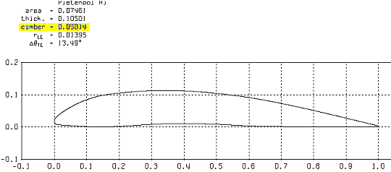
Figure 1 Profile of the Pietenpol Airfoil
Let’s compare it to a very famous airfoil used on the Piper Cub, the USA35-b airfoil:
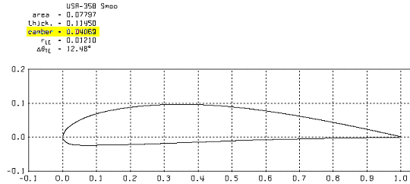

Figure 2 Profile of the USA35B "Cub" Airfoil
The first thing noticed is the curve or “undercamber” that is seen on the bottom of the Pietenpol airfoil and not on the bottom of the Cub USA35b airfoil. Generally speaking, the more camber an airfoil has, the more cruise lift, that is, the “design lift” which is the lift occurring at what is accepted as the general crusing speed of the wing, written as “cl” or sometimes “cld”. Notice that the Pietenpol airfoil has a camber of 0.05014 and the USA35b has a camber of 0.04069. We might assume from this, generally speaking, that the lift of the Pietenpol at cruise is higher than the lift of the Cub’s USA35b.
Well, let’s see!
Here is a diagram of the Pietenpol air pressures at what is close to the cruising speed of that airplane.

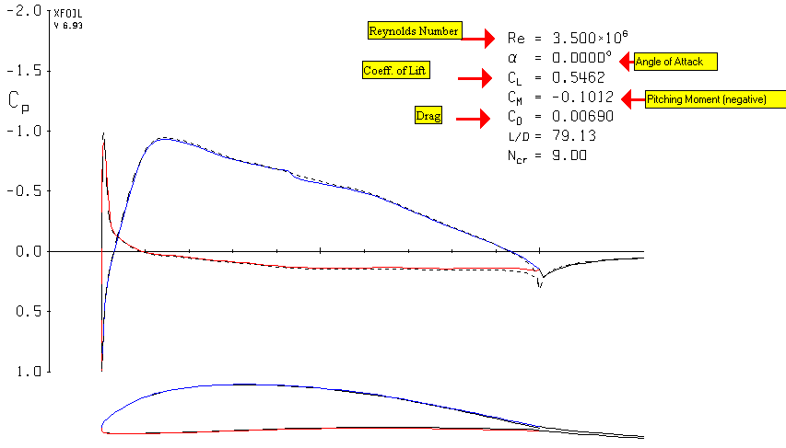
Figure 3 Pressure Coefficients of the Pietenpol Airfoil
Let’s talk about this. We’ll talk about Reynolds number later. The little “a” is alpha, and it is the angle of attack. Simple enough. Lift here is at 0 degrees angle of attack, or “zero degrees alpha”. The Cm is the pitching moment discussed earlier, and because it has a negative sign in front of it, it means there is a “tendency” of the airfoil to pitch down. Here, it is –0.1012, and is a lot of negative pitching moment. It is the price we pay for having a lot of camber and lift. Drag can be a real drag, but here it is 0.00690, or what we call “69 drag counts”. The NACA 23012 airfoil used on the Taylorcraft airplane, and known for being a pretty low drag airfoil, is about 61 drag counts (or 0.0061) using Xfoil software, but at 75 drag counts on other software programs. Let’s compare this to the Cub’s USA35b airfoil:
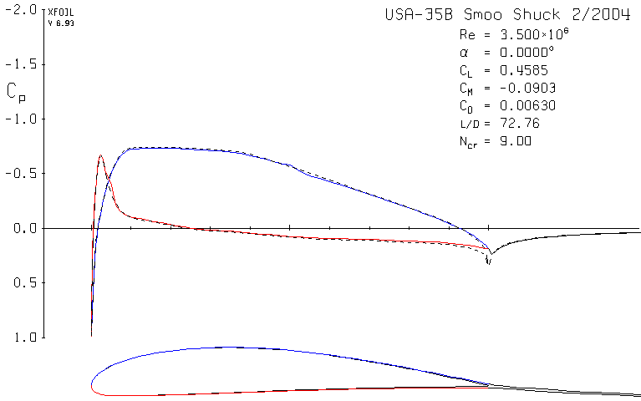
Figure 4 Piper Cub USA35b Airfoil at Re 3.5Million

Notice here on the USA35b, that the cl is .4585, less than the .5462 of the Pietenpol. The negative pitching moment, is less at -.0903. See a general connection here? The Pietenpol has greater camber, and greater lift than the USA35b. It also has greater negative pitching moment, which we don’t like. That produces a lot of trim drag on the airplane. That is a “force” if you like that causes the tail to “push down harder” to keep the nose up, and that means the main wing must actually create more lift, which causes more induced drag. I know, a bit complicated, but you want as little trim drag as you can stand and yet still have enough lift for your airplane’s purpose or mission. This is most of the reason why C. G. Taylor’s Taylorcraft flies 10 miles per hour faster than his Cub design: the Taylorcraft airfoil uses a lower drag airfoil, the NACA 23012, but this airfoil also has very little negative pitching moment, only about –0.012. If you have an airfoil which has less drag and significantly less negative pitching moment, you will also have buckets less trim drag as well, and, quite likely, significantly improved cruising speed. By the way, “buckets of drag” is not an acceptable unit of measure for collective drag, but I think you know what I mean.
You’ll notice on these figures above that the graph is of the change of local velocities of the airfoil, or “pressure coefficients” as they go down, or aft, the length of the airfoil. Blue lines are the pressures on the top of the airfoil, and red lines on the bottom of the airfoil. Thanks to our friends the Germans, the “lower” the pressure, the greater, or higher, the blue line is on the Y axis, or vertical axis. The greater the negative pressure, the higher is appears on the Y axis.
There is another exciting way of seeing the performance of airfoils on a graph. You want to know how much lift and drag and pitching moment the airfoil is creating at other angles of attack. For instance, in most general cases, when the aircraft and its wing are at an angle of attack of 14 to 16 degrees, the most lift the wing can create is being created then. This is a huge generalization, and aeronautical engineers reading this will groan at this explanation, but it serves our purposes at this point. If you are at a design cruising speed you are operating, usually, at what is called a higher Reynolds number than when you are flaring the aircraft, ready to land. Generally, the faster the aircraft is flying, the higher the Reynolds number. Lower speeds usually means lower Reynolds numbers. There is an explanation of the Reynolds number which involves viscous and inertial forces, and doesn’t apply to this specific article I’ve written here, but it is very, very important. You can find explanations of why it is important in detail in some of my other articles at my Yahoo! Web page which I will list at the end of this article.
The other exciting way of seeing your airfoil perform is to draw a “lift to drag” chart where we see the airfoils “polars”. These graphs look complicated at first, but they are so simple after you study them for a few minutes. These small graphs have a ton of information in them. Once you learn to read one, you can read and understand most others even though they are several different ways of illustrating them. I like the way presented by Xfoil. It lists the angle of attack, next to it the lift and drag and pitching moment. Ignore the other numbers for now. You don’t need them for our use here.
Here’s what we are going to do. I want to see how much lift the Pietenpol airfoil creates at each and every angle of attack close to or at the stall speed of the airplane. We will use that pesky Reynolds number to determine that, and for our purposes, it is a Reynolds number of 1.6 Million or “1.6 e6”. Here is what that shows:
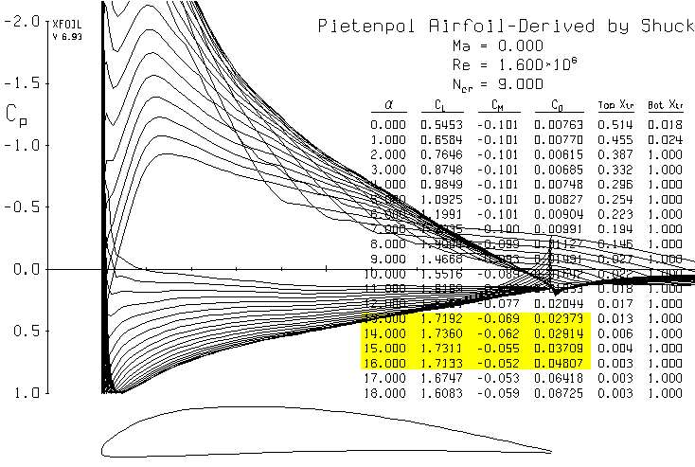
Figure 5 Lift to Drag Polars of the Pietenpol Airfoil

Neat, huh? Don’t let all the dozens of number throw you into apoplexia. Let’s just look at the yellow highlighted ones first. On the left are the angles of attack. So look down the left column until you see 14.000 degrees angle of attack. The lift there, which is Clmax at this Reynolds number, is 1.7360. Compared to most airfoils, that is a lot of lift! Notice here that the negative pitching moment has decreased a lot, which you’d expect at this point. Look at the drag: it is significantly higher than the 0.0069 we got at level cruise. Well, your wing is “angled up” significantly.
The Pietenpol aircraft has a very large wing and is relatively light. Why does it then need to produce so much lift? Because of the engine, mostly. It has very low horsepower. I’ve heard a lot of numbers bandied about that the Ford engine produces for this, but my guess (please, keep your spears to yourself) is that this particular engine is producing about 35 to 40 horsepower at best. It needs this much lift and a lot of wing to get up there. And it has no flaps. Flaps increase the lift at a lower angle of attack in the landing configuration, but also help slow the airplane down. Well, with no flaps, you have to have more wing area in order to produce the amount of lift you want in the landing configuration. Bernard Pietenpol wanted a safe airplane, and that is one that can be landed at a very slow speed. He also didn’t have a 10,000 foot runway to fly out of, so he needed as much possible lift on low horsepower that he could get. I’m speculating and putting words in his mouth here, but I think it’s reasonable to assume this is what he was looking for. Those folks reading this who knew him can fill me in better on this.
Notice that at these lower Reynolds numbers the drag goes up, the lift at cruise (or design lift) is less than at the higher Reynolds number where the aircraft speeds are generally higher, such as in cross-country operations. This is expected.
Okay, now it is time to compare Mr. P’s airfoil to the Cub airfoil. Let’s see what kind of hot-rod action we’re gonna get from this baby:
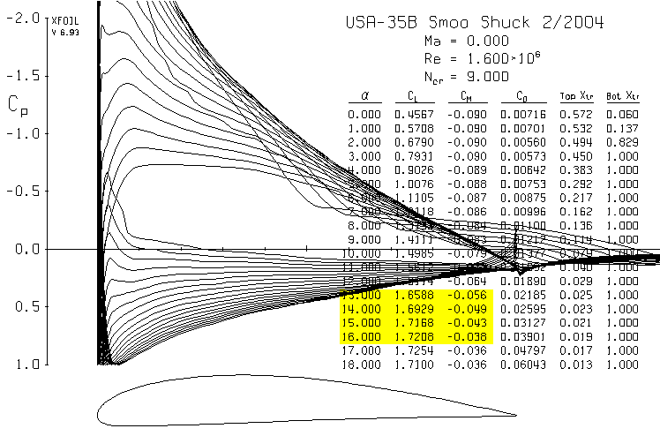
Figure 6 Lift Drag Polars of the Cub USA35b Airfoil at a Reynolds Number of 1.6 Million
Okay, let’s train our eyes to go to an alpha of zero and see what we have here: a cl of 0.4565, which is pretty darn good, a less negative pitching moment of –0.090 and a bit less drag than the Pietenpol at 71.6 drag counts. But what we really want to know at this Reynolds number is how this thing is gonna perform near stall. Let’s look:
At 14 degrees angle of attack we are producing a coefficient of lift of 1.69 and a negative pitching moment of –0.049. Not too shabby! We’ll ignore drag here for these purposes.
So, what do we have here? The Cub’s USA35b airfoil is relatively close in performance to the Pietenpol airfoil as far as in those Reynolds numbers we use in the landing configuration. What about at those Reynolds numbers where we really care: cruise speed!?
Let’s do some polars of both and see. We’ll start at a Reynolds number of 3.5 Million with the Pietenpol airfoil:

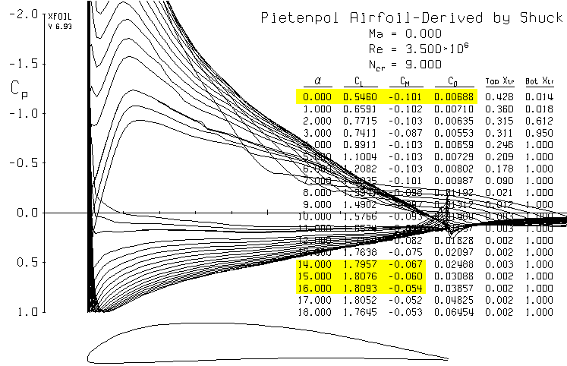
Figure 7 Lift Drag Polars of the Pietenpol Airfoil at Reynolds Number of 3.5 Million
What do we see at our cruise speed? We have cl of 0.5460, a negative pitching moment of –0.101 and drag of 68.8 drag counts. The lift is really great, but we pay a big price for it with very high negative pitching moments. The drag is reasonable considering the era in which this airfoil was designed. We’ll compare it now to the USA35b airfoil at the same Reynolds number.

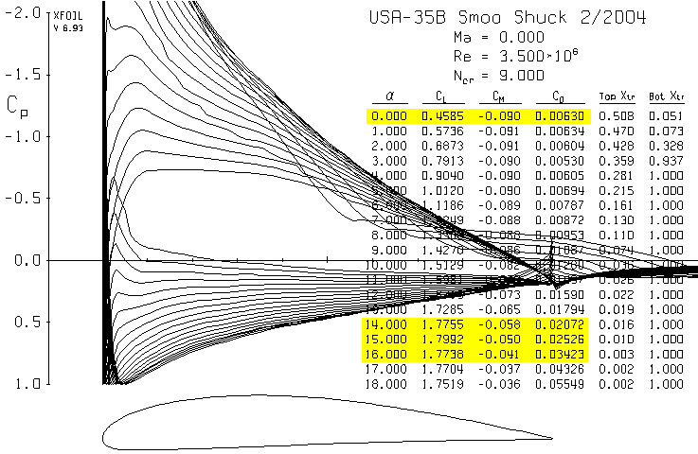
Figure 8 Lift Drag Polars of the Cub USA35b Airfoil at a Reynolds Number of 3.5 Million
Here we see that the cl is less, by quite a bit. It is only 0.4585 compared to the Pietenpol’s 0.5460. How might this affect climb out performance? That’s a bit more complicated because of other factors, but let’s look. Most climb out occurs in general aviation airplanes (and, again, this is a broad generalization) at a cl of 0.7 to about 0.8. We’ll go to those cl’s and see what we have at a Reynolds number for climbout of 2 million
Let’s guess at a Reynolds number for climbout of 2 million. Just a ballpark area:

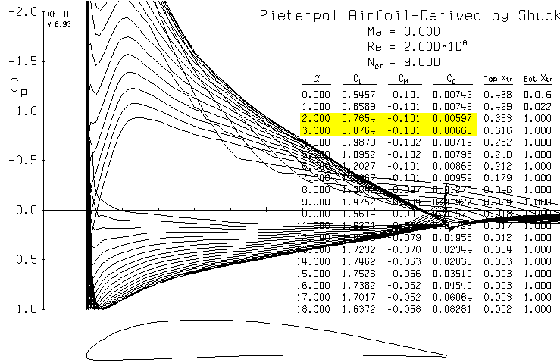
Figure 9 "Climbout" Lift Drag Polar of the Pietenpol Airfoil
And now for the USA35b airfoil:

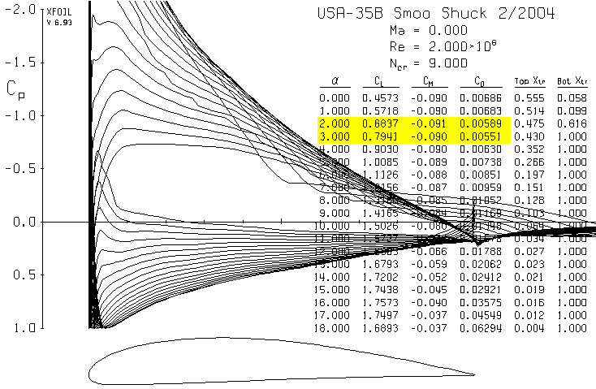
Figure 10 "Climbout" Lift Drag Polars of the USA35b Airfoil

There is an anomaly that you’ll often see in the older airfoils from the 1920’s and 1930’s. Often the drag will decrease at some of the early increasing angles of attack, and you’ll see that in both airfoils here. Remember, these airfoils were not derived by mathematics. They were derived through trial an error, eyeballing and guessing. Design by math came later. But, considering the technology and its limits of the times, they did a pretty darn good job. A lot of those old farts’ work is still pretty hard to beat today even with all our fancy technology. Remember, the Lockheed SR-71 was designed in the late 50’s and built in the early 60’s using only slide rules. Name one known unclassified aircraft that out performs it now 45 years later.

Conclusion
Okay, I hope that answers your questions on the performance of the Pietenpol airfoil. This isn’t meant to be more than just an article on how the airfoil performs, that is, its basic analysis. Because these terms and numbers may be new to you, I used the Cub USA35b airfoil for comparison because a lot of us know that aircraft well and are familiar, maybe more so, with it right now than with the Pietenpol. The Pietenpol is a delightful airplane. I went to Brodhead in 1991 to the Pietenpol fly in and it was terrific.
Here are some questions I anticipate folks are going to ask me:
- Can I just use the Cub USA35b airfoil instead of the Pietenpol airfoil for better performance since it has less drag and less negative pitching moment? Answer: Well, you could, but it wouldn’t be a Pietenpol anymore. And, the drag isn’t that much less that you’d see much if any difference in cruise. The USA35b airfoil here is 11.5% thick and the Pietenpol airfoil is only 10.5% thick, so the performance of the USA35b, if improved, could be from the fact that the wing would be thicker, therefore, lighter than the Pietenpol, too. What if we made the Pietenpol airfoil thicker so that its wing would be lighter? Uh, let’s save that for the next article, okay?
- Can I decrease the negative pitching moment of the Pietenpol airfoil and end up with less trim drag and have it fly faster. Yes. But you will have, as a consequence, less lift, too. If you want, we can answer this in another article if there is enough interest.
- Where is your website? It is at: http://groups.yahoo.com/group/airfoil/
You will find that it is more of a “files” website..messages are okay but not its strongpoint. Go to the “Files” section and you will see my articles on other airfoils, such as Harry Riblett’s high lift airfoils, the Lancair 4 airfoil, Roncz airfoils, Van’s RV airfoils, changing the old NACA airfoils to better suit our purposes, the Wittman W-10 Tailwind airfoil and others including a long article I wrote for the Quickiebuilder’s newsletter on canards and mainwing airfoils for the canard aircraft. Download them. They are free right now. I will be re-writing them with newer, updated information in late Fall to be published in a book next Spring of 2005. I will use slightly different analysis techniques and will expand a lot on the current articles. If you are as big a nerd as I am, you’ll enjoy them.
- Here’s the dumbest thing anyone ever said to me after reading my articles on my website: “You know, you’re a GENIUS! Why you’re the next John Roncz!” Please, just, please shut up. I am not on either account. Okay? If you enjoyed them after reading them, then I have accomplished my goal. It’s that simple.

Enjoy!

…..Mike Shuck

